D365 Data Layer – As Built

Table of Contents
1 Introduction 6
2 Solution Overview 7
2.1 Technical Components Overview 8
2.2 Data Sources 8
2.3 Azure Services 8
2.4 High-level load process overview 10
2.5 High-level components 13
3 Component overview 15
4 Data Load Setup & Configuration Pipelines 23
4.1 Bootstrap Process Main Pipeline 23
4.2 Bootstrap – Child Pipeline – PL_EXTRACT_D365_METADATA 25
4.3 Bootstrap – Child Pipeline PL_GENERATE_TABLES_LOAD_CONTROL 27
4.4 Bootstrap – Child Pipeline PL_GENERATE_TABLES_LOAD_CONTROL_AUDIT 29
4.5 PL_GET_AUDIT_ENTITYTYPE 32
4.6 Bootstrap – PL_D365_SCHEMA_DRIFT 34
4.7 Bootstrap – PL_GET_ENTITYDEFINITIONS 36
5 Logging & Notification Pipeline 40
5.1 PL_Notifications 40
6 Loading the tables from Synapse Link Dataverse 42
6.1 Audit Overall Summary 42
6.2 Loading tables from ICE & Workbench (Audit excluding) 46
6.3 Loading tables from ICE & Workbench Audit 49
6.4 Pipeline Name: PL_MAIN_STAGE_TRANSFORM_D365_AUDIT_NEW 53
7 Development Standards 56
7.1 Coding Standards 56
7.2 Development Toolset 56
8 Devops & CICD 57
8.1 Source Code Control 57
8.2 Repositories 57
8.3 Pipelines 57
8.4 Service Connections 57
8.5 Environments 58
8.6 Branching Strategy 58
9 Deployments – How to guide 61
9.1 Deployment in Synapse 61
9.2 Deployment in Synapse Dedicated SQL Pool 64
10 Process to access D365 data layer by new team 66
11 Weekly Data Reconciliation Pipeline Documentation 69
12 Key Considerations for Dedicated SQL Pool Deployment 72
12.1 Objects in Source Control 72
12.2 Handling Schema Drift 72
13 Required Access 74
14 Appendix – Glossary 75

Table of Figures
Figure 1 High level overview 7
Figure 2 High level Pipeline Flow 12
Figure 3 PL_MAIN_BOOTSTRAP 23
Figure 4 PL_EXTRACT_D365_METADATA 25
Figure 5 PL_GENERATE_TABLES_LOAD_CONTROL 27
Figure 6 PL_GENERATE_TABLES_LOAD_CONTROL_AUDIT 30
Figure 7 PL_D365_SCHEMA_DRIFT 34
Figure 8 PL_GET_ENTITYDEFINITIONS 37
Figure 9 PL_Notifications 40
Figure 10 PL_D365_STAGE 46
Figure 11 PL_AUDIT_ENHANCED 49
Figure 12 PL_MAIN_STAGE_TRANSFORM_D365_AUDIT_NEW 53
Figure 13 Feature isolation 59
Figure 14 - Release Isolation 59
Figure 15 Synapse Pipelines 62
Figure 16 Synapse Approval and deployment steps 62
Figure 17 Synapse Pipeline YAML 63

Document Control
Document history
Date | Authors | Version | Comment
30/09/2025 | Ravi Ahuja | 0.1 | Version for release
15/12/2025 | Ravi Ahuja | 0.2 | Added optimization for audit.

Audience
Name | Role | Company
Ravind Ramnath
Chhavi Sharma
Pranav Trivedi

Related documents
Document name | Author(s) | Version | Date

Introduction
The current D365 environment hosts over 40 bespoke workflows managing 260,000+ cases annually in TCO alone.
The lack of a conformed data layer limits analytical capabilities and SLA tracking for case management performance.
A strategic solution leveraging Azure Synapse Analytics, Synapse Link for Dataverse, and Power BI will enable a centralized data repository, supporting advanced analytics, compliance, and operational excellence.
The proposed architecture ensures secure data ingestion, processing, and visualization, enhancing decision-making and customer outcome tracking.
D365 Data Layer Design Documentation - Parent Page - TCO Business Performance - Confluence
Key Benefits:
- Unified Data Layer – Enables structured, scalable, and centralized data access for analytics for workflow programme.
- Advanced Performance Insights – Supports in-depth tracking of SLAs and workflow efficiencies.
- Improve performance by applying business rules, transformations, calculations at database level, instead of report level.
- Data storage is sustainable, manageable, accessible and can expand capacity as required and prevent data loss.
- Enhance the ability to report on historical data and trend and allow increased frequency of reporting
- Reduce manual processes and allow systematic data sourcing where possible.
- Security & Compliance – Ensures data integrity with industry-standard security (Vnet, RBAC, encryption).
- Scalability & Future Readiness – Provides flexibility to integrate new data sources, ensuring long-term sustainability.
- Improved Automation & CI/CD – Streamlined data pipelines and DevOps-driven deployments enhance operational agility.

Solution Overview
The Azure Data Platform for the D365 workflow program provides a centralized, scalable, and secure data architecture to enable insights, reporting, and advanced analytics for Dynamics 365 workflows. The solution ingests data from D365 (via Synapse Link for Dataverse) ensuring seamless integration with D365 Ice and Workbench applications.
Data is staged in Azure Storage, transformed in Azure Synapse Analytics, and visualized in Power BI, delivering comprehensive performance tracking and SLA monitoring. Security and compliance are embedded through RBAC, encryption, network isolation (Vnet/Subnet), and enterprise logging to meet BS11, OBR, and cybersecurity requirements. Disaster recovery and business continuity are ensured with locally-redundant backups and failover support.
This design empowers business teams with reporting and analytics for the workflow program provides insights on case management performance, optimizes operational efficiency, and provides a future-ready foundation for strategic decision-making.
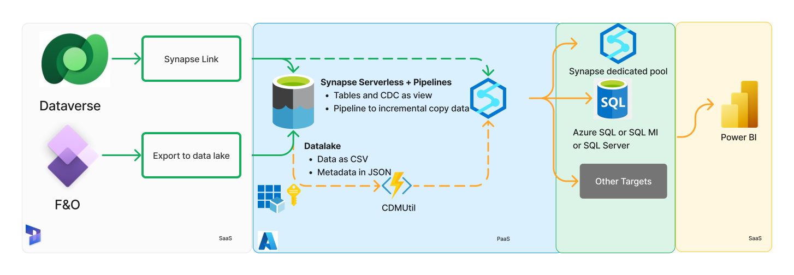

Figure 1 High level overview

- This image illustrates the integration of data from Dynamics 365 into Synapse using Synapse Link.
- On the left, Dataverse and Dynamics 365 feed entities and tables into Synapse Link.
- This data is processed through Synapse Serverless and Pipelines into an Azure Data Lake, where the data is stored as CSV and metadata in JSON format.
- From there, the data flows into Azure SQL, SQL Managed Instance, or SQL Server for further use, including integration with Power BI for data visualization.
- With the flexibility to integrate with external applications via T-SQL, Synapse Link simplifies the process of moving data between systems. This way, businesses can maintain their existing pipelines while benefiting from the improvements brought by Synapse Link

Technical Components Overview

Data Sources
Cloud SaaS D365 Application | Dynamics 365 ICE & New Instance | Azure Synapse Link for Dataverse. | Azure Vnet Gateways | MSI Authentication.

Azure Services
Category | Azure Service | Purpose
Data Ingestion -  All Services are part of Azure Synapse Analytics | Azure Synapse Link for Dataverse | Ingests real-time data from Dynamics 365
 | Azure Synapse Pipelines | Orchestrates ETL/ELT processes and data movement  Manages batch data movement and transformation
 | Azure Integration Runtime | Fetches data from SharePoint and APIs
Data Storage | Azure Data Lake Storage (ADLS Gen2) | Stores raw and intermediate data for processing
 | Azure Synapse Analytics | Stores and processes structured analytical data
Data Processing  All Services are part of Azure Synapse Analytics | Azure Synapse SQL Pools | This service is a part of Azure Synapse Analytics and Provides scalable data warehousing and query execution
 | Azure Synapse Spark Pools | Enables big data processing and transformations
Security & Compliance | Azure Active Directory (AD) | Manages user authentication and role-based access control (RBAC)
 | Azure Key Vault | Stores credentials, connection strings, and API keys securely
 | Azure Virtual Network (VNet) | Provides network isolation and secure communication
 | Azure Private Link & Subnets | Ensures private connectivity between Azure services
 | Azure Defender for SQL | Provides advanced threat protection for Synapse
Data Protection | Azure Storage Encryption (AES-256) | Encrypts data at rest
 | Azure Synapse Analytics Dynamic Data Masking | Protects sensitive data by masking PII
Monitoring & Logging | Azure Monitor | Collects telemetry data for health monitoring
 | Azure Log Analytics Workspace | Centralized log storage and analysis
 | Azure Application Insights | Tracks performance and usage analytics
Visualization & Reporting | Power BI | Provides interactive dashboards and reporting
 | Power BI Service Principal | Manages authentication for secure data access
Disaster Recovery & Backup | Azure Backup | Provides automated backups for data protection
Azure Devops | Repositories | Used for Source Control: Manages version control for source code, configuration files, and scripts.
 | CICD | Automates continuous integration and continuous deployment pipelines for data workflows and services, ensuring streamlined development and deployment processes.

High-level load process overview
The Implementation Design section provides the necessary details for engineers to implement a feature and serves as a resource for future engineers to understand the design, technology stack, and workflows, ensuring consistency and clarity in future development as a reference for onboarding new team members. It should clearly describe the technical approach, integration points, and how the feature will be built and tested.

System Overview:
The system is built on the Azure platform, leveraging a combination of Azure Synapse Analytics, Azure Storage, and secure data integration technologies to meet the requirements of TCO Business reporting.

Technologies and Platforms Involved:
- Azure Synapse Analytics: This serves as the core data platform, offering powerful analytics capabilities for processing and managing large-scale datasets. It is composed of several components:
- Dedicated SQL Pool: Used for high-performance data processing and reporting, ensuring optimized performance for complex queries.
- Serverless SQL Pool: Provides an on-demand query service for querying data stored in Azure Storage, without the need for provisioning infrastructure.
- Spark Pools: Employed for big data processing, enabling scalable analytics on large datasets, with support for various data processing and machine learning tasks.
- Azure Storage: Data is securely stored in Azure Storage accounts, using tables and blob storage to manage structured and unstructured data from multiple sources.
- Power BI: Consumes transformed data from Synapse, with reports hosted in a Premium Workspace and accessed via VNET Gateways.
- Azure DevOps: Manages CI/CD pipelines, version control, and deployment automation for Synapse pipelines.
- Logic Apps: Automates error notifications and custom alerts via Teams/Email for pipeline failures.
- Data Sources and Integrations:Dynamics 365 (D365): Integrated with Azure Synapse Link for Dataverse, Dynamics 365 data is ingested into Azure Storage tables. This integration ensures that data from D365 can be efficiently transferred and stored for reporting and analysis in the data platform.

Integration into the Larger System:
All data from Dynamics 365 is integrated into the Azure Synapse Analytics platform through pipelines, secure transfer mechanisms, and managed identities. The resulting curated data is processed, transformed, and made available for reporting and analysis, supporting critical business reporting. The end goal is to provide real-time, accurate, and secure data for the business, ensuring effective decision-making and operational efficiency.

Process and Sequence Diagrams:
Metadata-Driven ELT (Extract, Load, Transform) framework is essential for efficiently managing data integration processes. It standardises data extraction, loading, and transformation ensuring consistency, scalability, and reliability in our data platform.

Key Benefits
- Rapid Development and Deployment
- Configuration-Driven Transformation Rules
- Decoupling Logic from Code
- Automated Schema Evolution
- Reduced Maintenance Overhead
- Error Handling and Logging via Metadata
- Improved Data Governance
- Better Data Quality
- Scalability & Control
- Cost Efficiency
- Simplified Troubleshooting
- Version Control
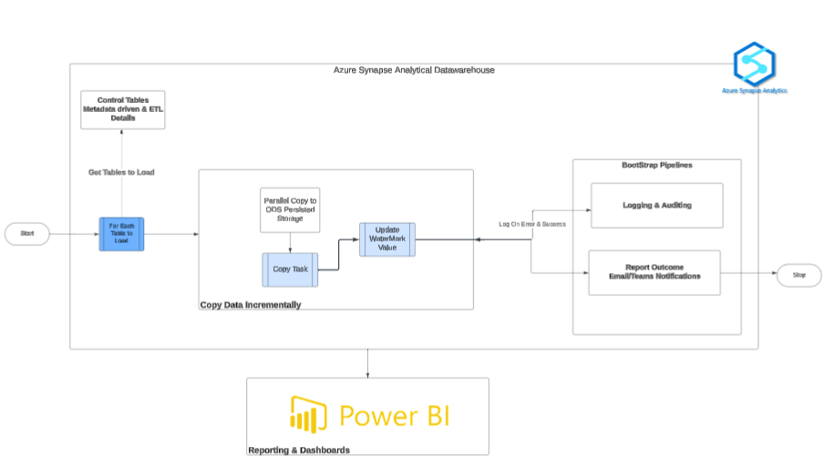
Figure 2 High level Pipeline Flow

Operational Steps:
- Metadata Framework Execution
  - Identifies tables to load based on configuration.
- Scheduled Data Ingestion
  - Each pipeline runs at a scheduled frequency based on business requirements.
  - Copy Activity runs in parallel for each table.
  - Data is copied into ODS tables in Synapse.
- Power BI reports hosted in Premium Workspace Accessed via Managed identity
- Error Handling & Logging
  - ETL log tables capture failures/errors per table.
  - Pipeline-level failures logged in Synapse Logging & Log Analytics.
- Custom Alerts & Notifications
- Synapse Triggers – Teams alerts for critical errors.
- Error Handling and Logging:
- Log Analytics Integration:
- Azure Log Analytics is used to collect, analyze, and visualize log data from all relevant sources within the system. It aggregates logs and telemetry from various Azure resources, including Azure Synapse Analytics, Azure Storage,KeyVault
- Log queries and alerts can be set up to monitor specific events, such as successful data transfers, processing times, data quality issues, and failure notifications. These logs are stored in Azure Monitor and can be easily queried to diagnose issues or perform audits.

- Error Handling and Fault Tolerance in Synapse:
  - Azure Synapse also captures logs for all the activities in the Synapse Pipeline and captures errors, providing insights into system performance, data flow status.
  - Synapse Pipelines are configured with robust error handling mechanisms to ensure data integrity and smooth processing. These mechanisms are critical in providing fault tolerance and ensuring that data is not lost or corrupted in case of unexpected errors during data copy, transformation, or load operations.
  - In Synapse Pipelines, the following techniques are employed to enhance fault tolerance:
    - Failure Alerts: Failure alerts are triggered automatically based on predefined conditions. These alerts notify relevant stakeholders (such as data engineers or operations teams) when a failure occurs, ensuring prompt intervention.
    - Retry Policies: For transient errors, retry policies are configured for copy activities and SQL stored procedures to attempt data operations multiple times before escalating the issue.
  - Fault Tolerant Data Copying: The copy activity in Synapse Pipelines is configured with fault tolerance options, such as staging error handling, where failed records are logged for reprocessing at a later stage, ensuring that the overall data pipeline is not disrupted.

High-level components
D365 Data Layer- Provisioned Infrastructure & Applications - TCO Business Performance - Confluence
Category | Azure Service | Purpose
Data Ingestion -  All Services are part of Azure Synapse Analytics | Azure Synapse Link for Dataverse | Ingests real-time data from Dynamics 365
 | Azure Synapse Pipelines | Orchestrates ETL/ELT processes and data movement  Manages batch data movement and transformation
 | Azure Integration Runtime | Fetches data from SharePoint and APIs
Data Storage | Azure Data Lake Storage (ADLS Gen2) | Stores raw and intermediate data for processing
 | Azure Synapse Analytics | Stores and processes structured analytical data
Data Processing  All Services are part of Azure Synapse Analytics | Azure Synapse SQL Pools | This service is a part of Azure Synapse Analytics and Provides scalable data warehousing and query execution
 | Azure Synapse Spark Pools | Enables big data processing and transformations
 | Azure Defender for SQL | Provides advanced threat protection for Synapse
Visualization & Reporting | Power BI | Provides interactive dashboards and reporting
 | Power BI Service Principal | Manages authentication for secure data access
Azure Devops | Repositories | Used for Source Control: Manages version control for source code, configuration files, and scripts.
 | CICD | Automates continuous integration and continuous deployment pipelines for data workflows and services, ensuring streamlined development and deployment processes.

Component overview

Pipelines
The following pipeline is created. The pipeline name and Synapse workspace component names are consistent across environments to simplify deployments. A separate synapse workspace is created per environment.
Azure Synapse Pipeline Name | Business Usage
D365/Audit/ PL_MAIN_STAGE_TRANSFORM_D365_AUDIT_NEW | The PL_MAIN_STAGE_TRANSFORM_D365_AUDIT pipeline manages the end-to-end audit data flow from Dynamics 365 into the Synapse Dedicated Pool. It dynamically identifies audit tables to extract, stages them in ADLS, and loads them into Synapse with row-level logging. The pipeline records both success and failure outcomes for traceability, sets error flags where required, and conditionally triggers downstream audit transformations. If errors occur, it sends notifications to ensure visibility. This enables a controlled, auditable, and compliant flow of Dynamics 365 audit data for further processing and reporting.
D365/Audit/PL_STAGE_D365 | The PL_STAGE_D365 pipeline is responsible for staging Dynamics 365 source tables into a dedicated Synapse environment. It dynamically retrieves tables to load, copies data from the source system to staging with optional incremental or full loads, and logs process outcomes. The pipeline includes error handling and notifications to ensure visibility and traceability of all data loads before downstream transformations.
Bootstrap /PL_MAIN_BOOTSTRAP | The PL_MAIN_BOOTSTRAP pipeline serves as the foundational bootstrap process for initializing D365 data extraction and staging for both the Ice and Workbench source systems. It orchestrates the end-to-end setup and preparation of metadata and table load controls required for downstream ETL operations.  Key activities include:  - Extract D365 Metadata – Retrieves metadata from the D365 source databases using the information schema to identify tables and their structures.  - Load D365 Tables – Generates table load control configurations for all standard tables, with options to drop and recreate target tables if needed.  - Load Audit Tables – Prepares and controls loading of audit-related tables for tracking changes in the source system.  - Load Audit Entities – Completes the audit pipeline by generating load controls for audit entities to ensure comprehensive data capture for compliance and reporting.  By executing these steps sequentially, PL_MAIN_BOOTSTRAP ensures that both source systems’ data and audit structures are fully prepared and staged in the D365 environment, providing a reliable foundation for subsequent ETL, analytics, and reporting processes.
Bootstrap /PL_GET_ENTITYDEFINITIONS | The PL_GET_ENTITYDEFINITIONS pipeline is designed to retrieve and update metadata for all entities in a D365 environment, specifically focusing on column display names. It ensures that the D365 data layer is aligned with the latest schema definitions, enabling accurate reporting, analytics, and downstream ETL processes.  Key functions of the pipeline include:  - Fetch Tables for Column Display Labels – Queries the configuration database to identify which tables require column display label updates.  - Retrieve Client ID – Securely obtains the client ID from Azure Key Vault to authenticate subsequent API requests.  - Get Entity Definitions – Iterates over each identified table and calls the D365 Web API to fetch entity and attribute metadata, including logical names and display labels.  - Update Column Display Names – Updates the staging database with the retrieved display names, ensuring consistency between D365 metadata and the data warehouse.  By automating these steps, PL_GET_ENTITYDEFINITIONS provides a reliable mechanism for keeping the staging layer metadata current, supporting accurate ETL operations, reporting, and analytics in the Workbench or Ice environments.
Bootstrap / PL_GET_AUDIT_ENTITYTYPE | The PL_GET_AUDIT_ENTITYTYPE pipeline is designed to capture and stage audit entity metadata from D365 environments into the dedicated Synapse pool for further processing and reporting. It ensures that all relevant audit entities are identified and recorded for downstream ETL and analytics tasks.  Key functions of the pipeline include:  - Extract Audit Entities – Queries the source D365 audit views to identify distinct entity types, capturing the mapping between the table catalog and entity IDs.  - Pre-Copy Cleanup – Deletes existing records in the target audit entity table for the given process ID to maintain data integrity and avoid duplicates.  - Load to Staging – Inserts the extracted audit entity metadata into the Config.AuditEntityList table in the Synapse dedicated pool, creating the table automatically if it does not exist.  - Data Handling – Ensures type conversions and allows for safe truncation of oversized data while maintaining data consistency.  By automating the extraction and staging of audit entity metadata, PL_GET_AUDIT_ENTITYTYPE provides a reliable foundation for audit tracking, compliance reporting, and analytics across the Ice and Workbench environments.
Bootstrap /PL_GENERATE_TABLES_LOAD_CONTROL_AUDIT | The PL_GENERATE_TABLES_LOAD_CONTROL_AUDIT pipeline is responsible for orchestrating the creation, management, and staging of audit tables for D365 environments within the Synapse dedicated pool. It ensures that all audit data is properly structured and available for downstream ETL processes, analytics, and compliance reporting.  Key functions include:  - Extract Audit Entities – Initiates by executing the PL_GET_AUDIT_ENTITYTYPE pipeline to retrieve distinct audit entity types from source systems.  - Determine Tables to Load – Fetches the list of audit tables that need to be generated based on metadata and process parameters.  - Generate Audit Tables – Iteratively creates the audit tables in the dedicated pool using stored procedures, updating control tables (MainControl and ControlFlow) to track execution order, flow type, and other metadata.  - Create Audit Views – Builds views on top of the audit tables to provide a structured interface for reporting and downstream ETL processes.  - Manage Table Lifecycle – Supports optional drop-and-recreate functionality to refresh tables and maintain consistency across audit datasets.  By automating the generation and management of audit tables and views, this pipeline provides a robust framework for capturing, staging, and monitoring audit data, ensuring data integrity, and enabling efficient reporting across Ice and Workbench environments.
Bootstrap /PL_GENERATE_TABLES_LOAD_CONTROL | Here’s a business description for the PL_GENERATE_TABLES_LOAD_CONTROL pipeline:  The PL_GENERATE_TABLES_LOAD_CONTROL pipeline orchestrates the preparation and staging of D365 tables for ETL processing within the Synapse dedicated pool. It ensures that only valid and metadata-aligned tables are generated and tracked for downstream ETL workflows.  Key functions include:  - Identify Tables to Load – Retrieves tables that exist in both Config.Metadata and Config.D365_metadata, ensuring alignment with the current D365 environment.  - Generate Metadata Records – Creates records in [config].[MDPTables] to maintain metadata for the tables being processed, supporting control and traceability.  - Generate Stage Tables & Update Control – Iteratively creates staging tables and updates the main control ([ELT].[MainControl]) and control flow ([ELT].[ControlFlow]) tables with execution order, flow type, functional area, and incremental load details.  By automating metadata generation, table creation, and control table updates, this pipeline provides a structured and reliable framework for staging D365 data, ensuring consistency, accuracy, and readiness for ETL and analytics processes.
Bootstrap /PL_EXTRACT_D365_METADATA | The PL_EXTRACT_D365_METADATA pipeline is responsible for extracting column-level metadata from D365 source databases and staging it into Synapse for downstream ETL and analytics processes. It captures structural information about tables and columns, ensuring that the data model and schema are accurately represented for operational and audit purposes.  Key functions include:  - Extract D365 Metadata (Workbench & ICE) – Retrieves table and column details from the D365 source system using the INFORMATION_SCHEMA.COLUMNS view, including data types, maximum lengths, numeric precision, nullability, and ordinal positions.  - Extract Audit Metadata – Extracts metadata for audit tables, enabling traceability of changes and historical data in both Workbench and ICE environments.  - Target Table Management – Before loading, the pipeline deletes existing metadata records in the target Synapse table to ensure the data remains current and consistent.  - Audit Catalog Variable Management – Dynamically sets the audit catalog name for audit metadata extraction, supporting flexible and automated handling of audit tables.  This pipeline ensures that D365 metadata is accurately captured, structured, and available in Synapse, supporting downstream ETL workflows, reporting, and audit compliance.
Bootstrap /PL_D365_SCHEMA_DRIFT | The PL_D365_SCHEMA_DRIFT pipeline monitors schema changes (schema drift) in D365 environments by comparing the current database structure against the expected metadata. It helps detect unauthorized or unexpected changes in table or column structures, ensuring data integrity and alerting relevant stakeholders.  Key functions include:  - Extract Metadata – Executes the PL_EXTRACT_D365_METADATA pipeline to extract the latest column-level metadata from D365 source systems into Synapse for comparison.  - Generate Schema Drift Notification JSON – Compares extracted metadata against existing reference metadata and generates a JSON payload capturing any differences, including details of altered tables or columns.  - Conditional Alerting – Checks if any schema drift was detected. If so, it triggers a Teams message to notify relevant users about the detected changes.  - Parameter-Driven Execution – Supports multiple environments and databases by allowing dynamic inputs for database name, table catalog, and target schema, ensuring flexibility across D365 environments.  This pipeline ensures timely detection and notification of schema changes, supporting governance, compliance, and operational integrity for D365 workloads.

Database Schemas

Schema | Purpose
Config | All configuration and bootstrap tables for setup and dynamic table generation
ELT | The schema for ELT operation, has all the control related tables along with logs and notification for ELT
ICE | The schema for the ICE source data
Workbench | The schema for the Workbench source data

Config & ETL Schema Tables
Schema | Table | Purpose
config | AuditColumns | Stores definitions of audit columns (e.g., CreatedOn, ModifiedOn, BatchID) appended to ODS, stage, and error tables for tracking changes.
config | AuditEntityList | Contains a list of entities/tables that are found in the objected_entitytype in audit tables
config | D365_Metadata | Holds metadata extracted from D365 tables, including entity names, attributes, data types, and relationships.
config | D365_metadata_Insert | Temporary staging table for loading new D365 metadata before merging into D365_Metadata.
config | D365ColumnDisplayNames | Stores user-friendly display names for D365 columns for reporting and UI mappings.
config | DynamicsEntityDefinitionMetadata | Contains detailed definitions of D365 entities, including logical names, primary keys, and ownership type.
config | MDPTableColumns | Stores metadata for columns of MDP-managed tables, including names, types, keys, and default values.
config | MDPTables | Maintains metadata for all MDP-managed tables, including creation scripts, select queries, merge clauses, and primary key definitions.
config | metadata | General-purpose metadata repository capturing additional mappings, relationships, or attributes not in other tables.
config | SchemaDriftmetadata | Tracks schema changes or drift in source tables to manage ELT adjustments and incremental loads.
ELT | ControlFlow | Stores current ELT pipeline steps, execution order, dependencies, and configuration for orchestrating workflows.
ELT | ControlFlowHistory | Historical log of executed ELT steps for auditing and troubleshooting purposes.
ELT | LandingColumnMapping | Maps source landing table columns to target staging/ODS table columns for ELT transformations used in Synapse Copy Activity.
ELT | LandingColumnMappingJson | Stores column mapping in JSON format for flexible parsing and dynamic ETL processing used in Synapse Copy Activity.
ELT | LogNotification | Logs notifications triggered during ETL/ELT execution, including errors, warnings, and info messages.
ELT | MainControl | Tracks the status and metadata of main ELT pipelines, including batch IDs, functional area, flow type, and execution state.
ELT | MainControlHistory | Historical record of MainControl executions for auditing and analysis.
ELT | MainProcessLogs | Detailed logs of individual process executions within pipelines, capturing success, failure, and performance metrics.
ELT | MetaTableColumns | Stores metadata about ELT-managed table columns for transformation and validation purposes.
ELT | NotificationConfig | Configuration table for ETL notifications, including recipients, channels, and triggers.
ELT | ProcessLog | Captures detailed execution logs for ELT processes, including start/end times, rows processed, and error details.

ICE and Workbench schema
The primary data columns for ICE and Workbench schemas are like for like to the source tables. They are not specified individually here.
The following system columns are added to the end of each ODS table in the ICE and Workbench schemas:
Field Name | Data Type | Default | Purpose
ODSPipelineID | String | None | PipelineID that loaded the record
ODSUpdatedDate | datetime2 | 31 December 2099 | Date record applies to

Security and Authentication
A managed identity account is created for use in all processes for the synapse workspace and granted the db_owner permission.

Triggers
Trigger | Pipeline | Business Usgae
trigger_audit_ice_201 | PL_MAIN_STAGE_TRANSFORM_D365_AUDIT_NEW | The trigger_audit_ice_201 is a scheduled daily trigger for Process ID 201, orchestrating the PL_MAIN_STAGE_TRANSFORM_D365_AUDIT pipeline. It extracts audit data from the IceAudit source system into the D365 Synapse environment for staging and transformation, ensuring up-to-date audit data is available each day for reporting and compliance purposes. The trigger runs at 4:00 AM NZST daily.
trigger_audit_workbench_200 | PL_MAIN_STAGE_TRANSFORM_D365_AUDIT_NEW | The trigger_audit_workbench_200 is a daily scheduled trigger for Process ID 200, executing the PL_MAIN_STAGE_TRANSFORM_D365_AUDIT pipeline. It extracts audit data from the WorkbenchAudit source system into the D365 Synapse environment for staging and transformation, ensuring that audit data from the Workbench system is updated daily for reporting and compliance purposes. The trigger runs at 4:30 AM NZST every day.
trigger_ice_schema_drift | PL_D365_SCHEMA_DRIFT | The trigger_ice_schema_drift is a daily scheduled trigger that executes the PL_D365_SCHEMA_DRIFT pipeline. It monitors and captures schema drift for the ICE database by comparing the current table structures against expected metadata. The results are stored in the config.SchemaDriftmetadata table, enabling proactive detection of changes in the source schema and supporting data integrity and ETL process reliability. The trigger runs at 4:00 AM NZST every day.
trigger_workbench_schema_drift | PL_D365_SCHEMA_DRIFT | The trigger_workbench_schema_drift is a daily scheduled trigger that runs the PL_D365_SCHEMA_DRIFT pipeline for the Workbench database. It tracks and logs schema changes by comparing the current table structures with expected metadata. Detected changes are recorded in the config.Schemadriftmetadata table to support data consistency, ETL reliability, and proactive monitoring. The trigger is scheduled to execute daily at 4:00 AM NZST.

trigger_stage_ice_others_xx | PL_STAGE_D365 | The trigger_stage_ice_others_xx is a 3 times a day scheduled trigger that runs the PL_STAGE_D365 pipeline for the Ice source system. It extracts data from the dataverse_wnzlprod_wnzl Synapse Link database and stages it into the D365 staging layer for subsequent ETL and analytics workflows. The trigger executes daily at xxx, ensuring data is available on time for processing and reporting.  To efficiently handle the current 750 tables, multiple triggers have been created, each processing a batch of 50 tables.
trigger_reference_workbench_100 | PL_STAGE_D365 | The trigger_reference_workbench_100 is a daily scheduled trigger that executes the PL_STAGE_D365 pipeline for the Workbench source system. It extracts data from the dataverse Synapse Link database and stages it into the D365 staging layer for downstream ETL and analytics processes. The trigger runs daily at 04:15 NZST, ensuring timely availability of data for processing, reporting, and analytical workflows.
trigger_stage_workbench_others_2 | PL_STAGE_D365 | The trigger_stage_workbench_others_2 is a daily scheduled trigger that runs the PL_STAGE_D365 pipeline for the Workbench source system. It extracts data from the dataverse Synapse Link database and stages it into the D365 staging layer to support downstream ETL, reporting, and analytics processes. This trigger executes daily at 06:00 NZST, ensuring that Workbench data is processed and available in a timely manner for subsequent workflows.

Data Load Setup & Configuration Pipelines

Bootstrap Process Main Pipeline
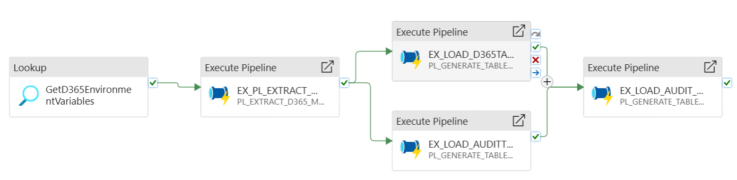
Figure 3 PL_MAIN_BOOTSTRAP
Pipeline Name: PL_MAIN_BOOTSTRAP
Folder: Bootstrap
The pipeline bootstraps the Dynamics 365 (D365) ingestion and staging framework. It extracts metadata from the D365 source, generates table structures (both transactional and audit), and loads them into Synapse for downstream processing. It is designed to initialize environments and ensure audit entities are created alongside core data tables.

Configurations
Type | Name | Default Value | Purpose
Parameter | TableCatalog | Ice | Identifies the source catalog (D365 instance name).
Parameter | DropAndRecreate | false | Flag to control whether tables are dropped and recreated during load.
Parameter | AuditADFProcessID | 201 | Identifies the ADF process ID for audit pipeline executions.

Activities
Activity Type | Activity Name | Purpose | Downstream Dependency
Lookup | GetD365EnvironmentVariables | Retrieves environment-specific configuration values for D365 (database name, workspace, etc.) from config.GetD365EnvironmentVariables. | Required by metadata extraction and audit load.
ExecutePipeline | EX_PL_EXTRACT_D365_METADATA | Extracts metadata from the D365 source database using Information Schema. Executes child pipeline PL_EXTRACT_D365_METADATA. | Runs after GetD365EnvironmentVariables.
ExecutePipeline | EX_LOAD_D365TABLES | Generates and loads control tables for transactional entities. Executes child pipeline PL_GENERATE_TABLES_LOAD_CONTROL. | Runs after metadata extraction.
ExecutePipeline | EX_LOAD_AUDITTABLE | Generates and loads control tables specifically for audit entities (<TableCatalog>Audit). Executes child pipeline PL_GENERATE_TABLES_LOAD_CONTROL. | Runs after metadata extraction.
ExecutePipeline | EX_LOAD_AUDIT_ENTITES | Loads audit entities into Synapse, linking audit tables with process tracking. Executes child pipeline PL_GENERATE_TABLES_LOAD_CONTROL_AUDIT. | Runs after EX_LOAD_D365TABLES and EX_LOAD_AUDITTABLE.

Flow Summary
- Initialize Environment – Load environment-specific details (database, workspace) from config.GetD365EnvironmentVariables.
- Extract Metadata – Run PL_EXTRACT_D365_METADATA to extract schema metadata from the D365 source.
- Generate Core Tables – Create and load transactional entity tables using PL_GENERATE_TABLES_LOAD_CONTROL.
- Generate Audit Tables – Create and load audit entity tables (<Catalog>Audit) using PL_GENERATE_TABLES_LOAD_CONTROL.
- Load Audit Entities – Finalize audit entity loads using PL_GENERATE_TABLES_LOAD_CONTROL_AUDIT, linked to the configured AuditADFProcessID.

Key Notes
- Metadata-driven design ensures new entities are automatically picked up without hardcoding.
- Audit framework runs alongside transactional tables, ensuring traceability.
- DropAndRecreate flag allows flexibility for initial bootstrap vs. incremental runs.
- Modular execution through child pipelines (PL_EXTRACT_D365_METADATA, PL_GENERATE_TABLES_LOAD_CONTROL, and PL_GENERATE_TABLES_LOAD_CONTROL_AUDIT).

Bootstrap – Child Pipeline – PL_EXTRACT_D365_METADATA
PL_EXTRACT_D365_METADATA – Extracts metadata (column definitions) from D365 source and audit databases using INFORMATION_SCHEMA.COLUMNS, and loads it into Synapse Dedicated SQL Pool for use in configuration and bootstrap processes.
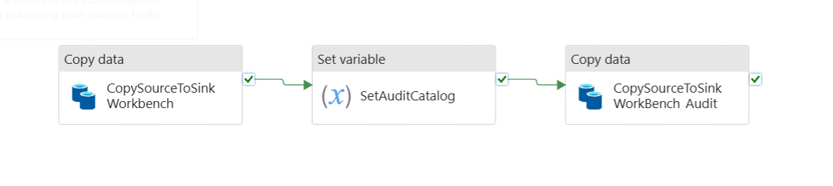
Figure 4 PL_EXTRACT_D365_METADATA

Configurations
Type | Name | Purpose
Parameter | DBName | Source D365 database name (default: dataverse_workbenchdev_unq03d83e083c57ee11a382002248942).
Parameter | TargetTableName | Destination table name in Synapse (default: metadata).
Parameter | TargetTableSchema | Destination schema in Synapse (default: config).
Parameter | TableCatalog | Source catalog name (default: Workbench).
Variable | AuditCatalogName | Derived catalog name for Audit DB (default set dynamically via expression).

Activities
Activity Type | Activity Name | Purpose | Database Object Used
Copy | CopySourceToSinkWorkbench | Extracts metadata (columns, data types, nullability, etc.) from D365 Workbench database and loads into Synapse. Performs delete on target table for the given catalog before insert. | INFORMATION_SCHEMA.COLUMNS from Workbench
SetVariable | SetAuditCatalog | Creates AuditCatalogName dynamically by appending Audit to the source catalog name (e.g., WorkbenchAudit). | Internal variable only
Copy | CopySourceToSinkWorkBench_Audit | Extracts metadata from the Audit database using the derived catalog name and loads into Synapse. Performs delete on target table for that catalog before insert. | INFORMATION_SCHEMA.COLUMNS from Audit DB

Flow Summary
- CopySourceToSinkWorkbench
  - Reads INFORMATION_SCHEMA.COLUMNS from the Workbench DB.
  - Deletes old Workbench catalog entries from [config].[metadata].
  - Inserts fresh column metadata into Synapse.
- SetAuditCatalog
  - Constructs Audit catalog name (e.g., WorkbenchAudit).
- CopySourceToSinkWorkBench_Audit
  - Reads INFORMATION_SCHEMA.COLUMNS from the Audit DB.
  - Deletes old Audit catalog entries from [config].[metadata].
  - Inserts fresh Audit metadata into Synapse.
- Completion
  - Both Workbench and Audit metadata are now consolidated into Synapse for downstream use.

Notes
- Metadata scope: Captures column-level details (table name, schema, column name, data type, max length, precision, scale, nullability).
- Primary keys: All columns default to IsPrimary = 0 (keys not determined at this stage).
- Pre-copy scripts: Ensure old catalog metadata is deleted before inserting new data.
- Destination: Metadata stored in Synapse [config].[metadata] for both Workbench and Audit catalogs.
- Folder: Pipeline is part of the Bootstrap folder, supporting setup and initialization tasks.

Bootstrap – Child Pipeline PL_GENERATE_TABLES_LOAD_CONTROL
PL_GENERATE_TABLES_LOAD_CONTROL – Generates metadata records, creates Stage tables, and updates orchestration control tables ([ELT].[MainControl] and [ELT].[ControlFlow]) from configuration and D365 metadata.
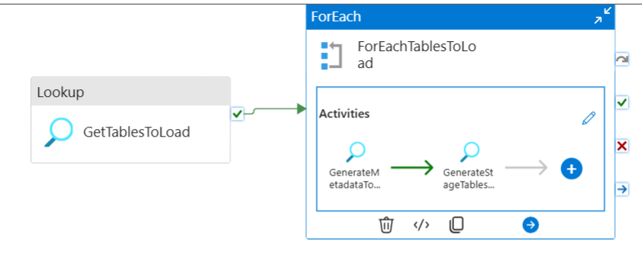
Figure 5 PL_GENERATE_TABLES_LOAD_CONTROL

Configurations
Type | Name | Purpose
Parameter | TableCatalog | Source catalog to process (default: Workbench).
Parameter | DropAndRecreate | Boolean flag to control whether Stage tables should be dropped and recreated (default: true).

Activities
Activity Type | Activity Name | Purpose | Database Object Used
Lookup | GetTablesToLoad | Retrieves list of tables that exist in both config.metadata and config.d365_metadata. | [config].[Get365TablesToGenerateFromMetadata]
ForEach | ForEachTablesToLoad | Iterates through tables returned by GetTablesToLoad. | Uses Lookup output
Lookup (inside ForEach) | GenerateMetadataToConfigTable | Creates/updates metadata record in [config].[MDPTables] for each table. | [config].[GenerateMetadataToConfigTable]
Lookup (inside ForEach) | GenerateStageTablesAndUpdateMainControl | Reads [config].[MDPTables] entry and merges corresponding control records into [ELT].[MainControl] and [ELT].[ControlFlow]. | [config].[GenerateStageTablesAndUpdateMainControl]

Notes
- Dynamic iteration: Uses output of GetTablesToLoad to drive metadata generation and control table updates.
- Metadata to control flow linkage: Ensures that metadata in [config].[MDPTables] aligns with orchestration tables for downstream processing.
- Drop/recreate support: Controlled by pipeline parameter DropAndRecreate to allow flexibility for table refresh scenarios.
- Execution metadata: Parameters like ExecutionOrder, ExecutionOrderGroup, FunctionalArea, FlowType, and IncrementalCol are dynamically populated from the table list.
- Folder: Pipeline is part of the Bootstrap folder, handling environment initialization and orchestration setup.

Flow Summary
- GetTablesToLoad
  - Executes stored procedure [config].[Get365TablesToGenerateFromMetadata].
  - Returns a list of tables that exist in both config.metadata and config.d365_metadata.
  - Passes the result set into the ForEachTablesToLoad activity.
- ForEachTablesToLoad (runs in parallel for each table)
  - Step 1: GenerateMetadataToConfigTable
    - Calls [config].[GenerateMetadataToConfigTable].
    - Creates or updates a record in [config].[MDPTables] containing:
      - Table creation scripts (Stage/ODS/Error).
      - Select queries and merge logic.
      - Key definitions and incremental load settings.
    - Ensures each table has its metadata centrally managed.
  - Step 2: GenerateStageTablesAndUpdateMainControl
    - Calls [config].[GenerateStageTablesAndUpdateMainControl].
    - Uses metadata from [config].[MDPTables] to:
      - Create or refresh Stage tables.
      - Insert orchestration metadata into [ELT].[MainControl].
      - Insert execution metadata (execution order, flow type, dependencies, incremental col) into [ELT].[ControlFlow].
    - Aligns orchestration framework with current metadata configuration.
- Completion
  - Once all ForEach iterations complete, the pipeline ensures that:
    - All eligible tables have Stage tables in place.
    - [ELT].[MainControl] and [ELT].[ControlFlow] are updated and ready for downstream ETL execution.

Bootstrap – Child Pipeline PL_GENERATE_TABLES_LOAD_CONTROL_AUDIT
The PL_GENERATE_TABLES_LOAD_CONTROL_AUDIT pipeline orchestrates the creation, staging, and orchestration of audit tables for D365 audit data. It ensures audit tables are generated and updated in the stage environment, with metadata tracked in orchestration control tables [ELT].[MainControl] and [ELT].[ControlFlow]. The pipeline supports sequential execution to maintain table dependencies and order of processing.
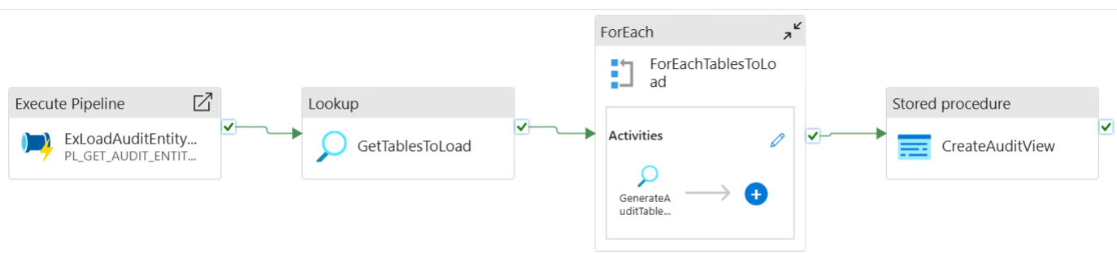
Figure 6 PL_GENERATE_TABLES_LOAD_CONTROL_AUDIT

Configuration
Configuration Type | Name | Type | Default / Description
Parameter | TableCatalog | String | WorkbenchAudit – Source table catalog for audit tables
Parameter | DropAndRecreate | Boolean | true – Indicates whether to drop and recreate tables
Parameter | ADFProcessID | String | ADF process identifier for orchestration
Parameter | AuditDBName | String | Source database name containing audit data
Variable | AuditCatalogName | String | Stores dynamic audit catalog name during execution

Activities
Activity Type | Name | Purpose | Database Object
Execute Pipeline | ExLoadAuditEntityType | Extracts distinct audit entity types to parameterize downstream activities | N/A (Pipeline PL_GET_AUDIT_ENTITYTYPE)
Lookup | GetTablesToLoad | Retrieves audit tables to process from metadata | Stored Procedure: [Config].[Get365AuditTablesToGenerateFromMetadata]
ForEach (Sequential) | ForEachTablesToLoad | Iterates over each table returned from GetTablesToLoad | N/A
Lookup | GenerateAuditTablesAndUpdateMainControl | Generates audit stage tables and updates orchestration metadata | Stored Procedure: [config].[GenerateAuditTablesAndUpdateMainControl]
Stored Procedure | CreateAuditView | Creates or refreshes audit views for standardized access | Stored Procedure: [Config].[CreateAuditView]

Flow Summary
- ExLoadAuditEntityType
  - Executes child pipeline to identify distinct entity types from the audit data.
  - Populates parameters like ADFProcessID, TableCatalog, and AuditDBName for downstream use.
- GetTablesToLoad
  - Runs a stored procedure to retrieve audit tables that exist in both metadata and audit datasets.
  - Provides the input list for sequential iteration in ForEachTablesToLoad.
- ForEachTablesToLoad (Sequential Execution)
  - Iterates over each audit table to perform table generation and orchestration.
  - GenerateAuditTablesAndUpdateMainControl:
    - Uses metadata from [config].[MDPTables].
    - Generates/updates audit stage tables.
    - Updates [ELT].[MainControl] and [ELT].[ControlFlow] with execution metadata including:
      - Execution order and group
      - Flow type and functional area
      - Incremental column information
      - Source view name

CreateAuditView
  - Creates or refreshes views to standardize access to audit tables.
  - Executes after all audit tables have been generated and orchestration metadata updated.

Notes
- The pipeline is designed for sequential processing to maintain dependencies among audit tables.
- Drop-and-recreate functionality is parameterized for flexibility.
- Orchestration metadata ensures downstream pipelines can track processing status and execution order.
- Audit tables are maintained separately from core D365 tables to ensure historical tracking and compliance.

PL_GET_AUDIT_ENTITYTYPE
The PL_GET_AUDIT_ENTITYTYPE pipeline extracts unique entity types from the D365 Audit tables and stores them in a dedicated staging table (Config.AuditEntityList). This pipeline ensures that the audit entity types are captured and maintained in Synapse for downstream processing, such as generating audit-based tables, incremental loads, and metadata-driven orchestration.

Configuration
Configuration Type | Name | Type | Default / Description
Parameter | DBName | String | dataverse_devsupport_orge364fa83 – Default D365 source database
Parameter | TableCatalog | String | ICE – Source catalog used in D365
Parameter | ADFProcessID | String | 201 – Unique ADF process identifier
Variable | vSourceQuery | String | Query template for selecting distinct EntityType from [dbo].[audit]
Variable | vDeleteQuery | String | Query template for cleaning existing entries in Config.AuditEntityList based on ADFProcessID

Activities
Activity Type | Name | Purpose | Database Object
Lookup | GetD365EnvironmentVariables | Retrieves environment-specific database details for the pipeline execution | Stored Procedure: config.GetD365EnvironmentVariables
Copy | CopyAuditEntities | Extracts distinct entity types from the D365 Audit table and inserts into Config.AuditEntityList | Source: [dbo].[audit]  Sink: Config.AuditEntityList

Flow Summary
- GetD365EnvironmentVariables
  - Fetches the database name and connection details for the specified TableCatalog.
  - Output provides the database name used by the CopyAuditEntities activity.
- CopyAuditEntities
  - Performs a SELECT DISTINCT on objectid_entitytype from the [dbo].[audit] table in the D365 source.
  - Deletes existing entries in Config.AuditEntityList for the current ADFProcessID.
  - Inserts the latest entity types into Config.AuditEntityList.
  - Ensures that the staging table has a clean and accurate set of audit entity types for downstream pipelines.

Notes
- The pipeline uses dynamic SQL variables (vSourceQuery, vDeleteQuery) to parameterize queries for flexibility across different TableCatalog and ADFProcessID values.
- Supports incremental refresh by deleting previous rows for the current ADFProcessID before inserting new records.
- The pipeline is dependent on environment metadata fetched via GetD365EnvironmentVariables to dynamically target the correct database.
- Ensures metadata-driven orchestration for audit table processing downstream, such as in PL_GENERATE_TABLES_LOAD_CONTROL_AUDIT.

Bootstrap – PL_D365_SCHEMA_DRIFT
The PL_D365_SCHEMA_DRIFT pipeline monitors schema changes in D365 tables by extracting metadata and detecting schema drift between source and stage tables. If any drift is detected, the pipeline generates a notification JSON and sends alerts to a Teams channel. This ensures timely awareness of schema changes and supports proactive adjustments in downstream ETL processes.
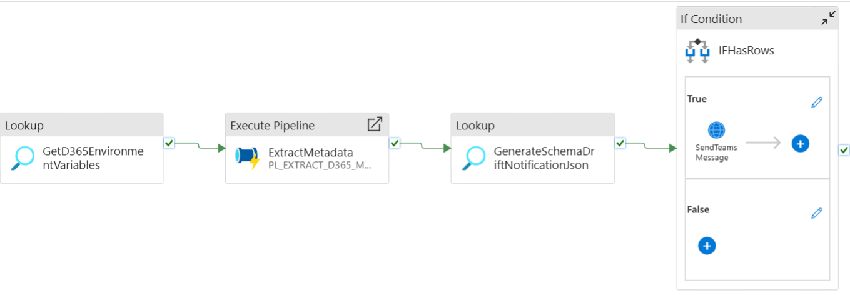
Figure 7 PL_D365_SCHEMA_DRIFT

Configuration
Configuration Type | Name | Type | Default / Description
Parameter | TargetTableName | String | SchemaDriftmetadata – Target table for storing extracted metadata
Parameter | TargetTableSchema | String | config – Target schema in Synapse
Parameter | TableCatalog | String | ice – D365 source catalog
Parameter | TeamsURL | String | Default Teams webhook URL for sending notifications
Concurrency | N/A | Integer | 1 – Ensures single-threaded execution for pipeline

Activities
Activity Type | Name | Purpose | Database Object
Lookup | GetD365EnvironmentVariables | Retrieves environment-specific connection information and database names | Stored Procedure: config.GetD365EnvironmentVariables
Execute Pipeline | ExtractMetadata | Extracts D365 table metadata to target stage table | Pipeline: PL_EXTRACT_D365_METADATA
Lookup | GenerateSchemaDriftNotificationJson | Compares extracted metadata and generates JSON notification if schema drift exists | Stored Procedure: [ELT].[GenerateSchemaDriftNotificationJson]
If Condition | IFHasRows | Checks if any schema drift rows exist | N/A
Web Activity | SendTeamsMessage | Sends Teams notification with schema drift details if detected | N/A (uses Teams webhook)

Flow Summary
- GetD365EnvironmentVariables
  - Fetches the database name and environment details for the specified TableCatalog.
  - These values are passed to the ExtractMetadata activity.
- ExtractMetadata
  - Executes the child pipeline PL_EXTRACT_D365_METADATA.
  - Extracts table and column-level metadata from the D365 source catalog.
  - Loads the metadata into the target stage table defined by TargetTableName and TargetTableSchema.
- GenerateSchemaDriftNotificationJson
  - Compares the newly extracted metadata with existing stage metadata to detect schema changes.
  - Generates a JSON message for Teams if schema drift is detected.
- IFHasRows
  - Evaluates if the GenerateSchemaDriftNotificationJson activity produced any rows (i.e., schema changes detected).
  - If true, triggers the SendTeamsMessage activity to post the JSON notification to Teams.
- SendTeamsMessage
  - Posts a JSON-formatted message to the configured Teams webhook.
  - Ensures that stakeholders are immediately informed of any schema drift detected in D365 tables.

Notes
- Pipeline enforces single-threaded execution to avoid concurrency issues during metadata extraction.
- Teams notification is parameterized via TeamsURL for flexibility across environments.
- All metadata comparisons and drift notifications are performed at column-level granularity.
- Supports proactive monitoring for ETL reliability, allowing teams to handle schema changes before they impact downstream processes.

Bootstrap – PL_GET_ENTITYDEFINITIONS
The PL_GET_ENTITYDEFINITIONS pipeline fetches metadata for D365 entities, including column display labels. It iterates over all relevant tables and calls the D365 Web API to retrieve entity definitions, storing the results in Synapse via a stored procedure. This enables consistent column naming, metadata management, and downstream reporting/processing.
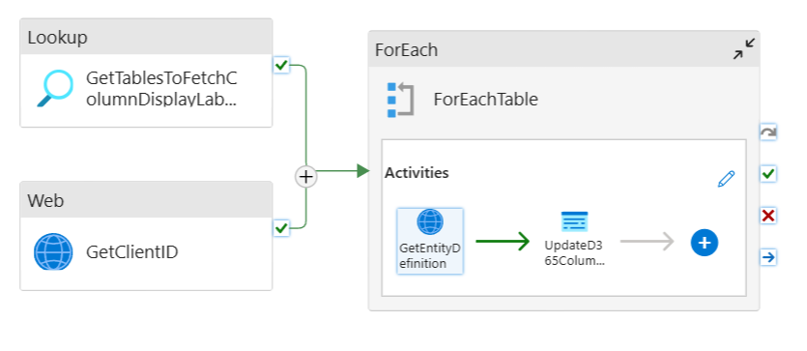
Figure 8 PL_GET_ENTITYDEFINITIONS

Configuration
Configuration Type | Name | Type | Default / Description
Parameter | TenantID | String | Azure AD Tenant ID for authentication
Parameter | BaseURL | String | Base URL for D365 Web API
Parameter | URLEntityDefinition | String | API path template to fetch entity definitions (with {entity} placeholder)
Parameter | TableCatalog | String | Workbench – Catalog for table selection
Parameter | KeyVaultSecretURL | String | Key Vault URL for fetching SPN secrets
Variable | URL | String | Dynamic URL built per entity for API calls

Activities
Activity Type | Name | Purpose | Database / Object / API
Lookup | GetTablesToFetchColumnDisplayLabels | Retrieves tables from metadata for which column display labels need to be fetched | Stored Procedure: Config.GetTablesToFetchColumnDisplayLabels
WebActivity | GetClientID | Fetches Service Principal client ID from Key Vault for API authentication | Azure Key Vault
ForEach | ForEachTable | Iterates over each table returned from GetTablesToFetchColumnDisplayLabels | N/A
WebActivity | GetEntityDefinition | Calls D365 Web API to get entity definitions for a table | D365 Web API
SqlServerStoredProcedure | UpdateD365ColumnDisplayNames | Stores entity definition JSON into Synapse for metadata / column label management | Stored Procedure: Config.UpdateD365ColumnDisplayNames

Flow Summary
- GetTablesToFetchColumnDisplayLabels
  - Retrieves all tables from the metadata that require entity definitions.
- GetClientID
  - Calls Key Vault to retrieve the client ID for authenticating D365 API calls.
- ForEachTable (Batch size 5)
  - Iterates over each table returned by the lookup activity.
  - GetEntityDefinition: Calls the D365 Web API using Service Principal authentication to fetch entity definition JSON.
  - UpdateD365ColumnDisplayNames: Passes the JSON blob and relevant table metadata to the stored procedure Config.UpdateD365ColumnDisplayNames, storing display labels in Synapse.
- Execution ensures that D365 entity metadata, including display names, is consistently captured and maintained in Synapse for downstream ETL, reporting, and UI labeling purposes.

Notes
- The pipeline supports parallel execution with batchCount = 5 for faster processing.
- Service Principal authentication ensures secure access to D365 Web APIs.
- Metadata is dynamically parameterized using TableCatalog, TenantID, and BaseURL.
- Entity definitions are stored as JSON, enabling downstream parsing and transformations.
- Helps maintain alignment between D365 entity structures and Synapse metadata tables.

Logging & Notification Pipeline

PL_Notifications
Pipeline handles notifications for pipeline executions in Synapse. It checks for errors in a given pipeline run and sends a Teams message if any errors are detected. It leverages a stored procedure to generate the notification JSON and posts it to Microsoft Teams using a webhook.
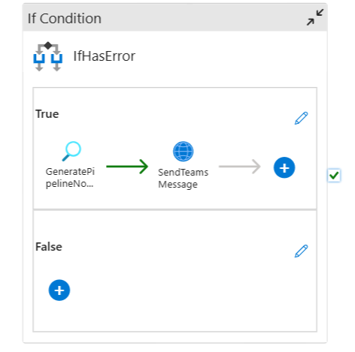
Figure 9 PL_Notifications

Configuration
Configuration Type | Name | Type | Default / Description
Parameter | PipelineRunId | String | ID of the pipeline run
Parameter | PipelineName | String | Name of the pipeline
Parameter | PipelineDuration | String | Duration of the pipeline
Parameter | PipelineMessage | String | Custom message
Parameter | ErrorCount | Int | Number of errors in the pipeline execution
Parameter | TeamsURL | String | Teams webhook URL to send the notification
Variable | messageCard | String | Stores the JSON message to send to Teams

Activities
Activity Type | Name | Purpose | Database / Object / API
IfCondition | IfHasError | Checks if ErrorCount > 0. Executes notification flow if true. | N/A
Lookup | GeneratePipelineNotificationJson | Calls stored procedure to generate Teams message JSON for the pipeline failure | Stored Procedure: [ELT].[GeneratePipelineNotificationJson]
WebActivity | SendTeamsMessage | Posts the generated JSON message to Teams if errors exist | Teams Webhook via HTTP POST

Flow Summary
- IfHasError
  - Evaluates: @greater(pipeline().parameters.ErrorCount,0)
  - If true, executes the following activities:
- GeneratePipelineNotificationJson
  - Generates the Teams-compatible JSON message using the stored procedure [ELT].[GeneratePipelineNotificationJson].
  - Inputs: Environment (DataFactory), PipelineRunId, PipelineName, Duration, Message (FAILED).
- SendTeamsMessage
  - Sends the JSON message to the specified Teams webhook URL using a POST request.
  - Uses the message generated in the previous step as the request body.
- No action occurs if ErrorCount = 0.

Notes
- The pipeline is error-driven, triggering notifications only if failures occur.
- Stored procedure ensures the Teams message JSON is dynamically generated per pipeline run.
- WebActivity uses AutoResolveIntegrationRuntime for secure outbound HTTP calls.
- Simplifies monitoring and alerting for Synapse pipeline executions.

Loading the tables from Synapse Link Dataverse

Audit Overall Summary

Purpose & Context
The D365 Audit data layer centralizes audit history (Ice + Workbench) from the Audit workspace (dl-prod-synw). Given the ~1 TB volume, the solution implements two complementary load strategies:
- Full (historical) load for the last two years using serverless SQL over Parquet.
- Incremental load using Delta Lake _delta_log metadata to discover and load only new/changed Parquet files.
This balances completeness (historical backfill) with cost-aware, operationally efficient incremental updates.

Load Strategies

A. Full Load (Historical, 2 Years)
- Driver: Pipeline PL_MAIN_STAGE_TRANSFORM_D365_AUDIT_NEW.
- Source: Serverless SQL Pool over Parquet in dl-prod-synw.
- Filter: SinkModifiedOn and CreatedOn >= current_date - 2 years.
- Behavior: Scans across many Parquet files; serverless auto-scales to satisfy the query—expensive but necessary for initial backfill or large resyncs.
- Outcome: Loads/stages data, then distributes to entity-level audit tables.

B. Incremental Load (Operational)
- Driver: Pipeline PL_AUDIT_ENHANCED (you shared earlier).
- Source: Delta Lake _delta_log JSON in dl-prod-synw.
- Steps:
  - Ingest delta log JSON → [ELT].[AuditChangeLogData].
  - Explode JSON via OPENJSON → [ELT].[AuditFileStatus] (file names, folder paths, statuses).
  - Traverse file list:
    - Create a per-file table (name = Parquet file name, e.g. part-00000-5c63...parquet).
    - Load file contents to that table.
  - Entity discovery: Lookup which entities are present in the file; filter the per-file table and load each entity’s audit target.
  - Idempotency & failure safety:
    - Flag the file as loaded in [ELT].[AuditFileStatus].
    - Log each loaded entity from that file in [ELT].[LogAuditEntitiesInFiles] so retries don’t re-load.
  - Watermarking: Track latest delta-log filedate and always pick only newer logs.

Core Tables
Schema.Object | Role | Key Columns / Notes
[ELT].[AuditChangeLogData] | Raw store of _delta_log commit records. | Mapped from JSON: commit timestamp, operation, added path, partition info, etc. Used as the authoritative delta-log snapshot for a run.
[ELT].[AuditFileStatus] | Exploded list of files from delta logs + state tracking. | FileName, FolderPath, Status/Flag (e.g., Pending/Loaded/Failed), PipelineRunID, timestamps. Drives traversal of new/changed files.
[ELT].[LogAuditEntitiesInFiles] | Ensures an entity found in a specific file is only loaded once. | (FileName, EntityName, LoadedFlag, LoadedOn, PipelineRunID). Prevents duplicate entity loads after retries or partial failures.
<Per-file table> | Temporary/stage table named exactly as the file (e.g., part-00000-...parquet). | Holds raw rows from one file to filter and move to entity audit tables. Created on demand, dropped/retained per policy.
<Entity audit tables> | Destination tables for each entity (Ice, Workbench). | Loaded from per-file tables with entity-specific filtering/business rules.

Pipelines & Responsibilities

PL_MAIN_STAGE_TRANSFORM_D365_AUDIT_NEW (Full Load)
- Purpose: Two-year backfill via serverless SQL pool.
- Key Tasks:
  - Apply date filters (SinkModifiedOn, CreatedOn).
  - Stage and transform data to entity audit tables.
- Trade-offs: High cost (broad file scans), but comprehensive.

PL_AUDIT_ENHANCED (Incremental, delta-log driven)
- Purpose: Load only newly added/changed files discovered via delta logs.
- Key Tasks (as implemented):
  - Ingest _delta_log into [ELT].[AuditChangeLogData].
  - Explode JSON → [ELT].[AuditFileStatus].
  - Generate/refresh load control (catalog <SourceSystem>Audit).
  - Construct file list and orchestrate loading from ADLS.
  - Update watermark and send error notifications when needed.

Operational Considerations & Best Practices
- Cost & Performance
- Full load (serverless SQL) is expensive due to wide scans; consider:
  - Narrowing partitions (date or entity).
  - Using filename/path predicates when possible.
  - Scheduling full loads off-peak with workload management.
- Incremental load leverages _delta_log to avoid scanning the lake:
  - Only files created/modified since the last watermark are processed.
  - Keep _delta_log ingestion fast by pruning date ranges and avoiding large JSON bursts.
- Reliability & Idempotency
- Two-level deduplication:
  - File-level via [ELT].[AuditFileStatus] flags.
  - Entity-in-file level via [ELT].[LogAuditEntitiesInFiles].
- Watermarking on the delta-log filedate guarantees forward-only progression.
- Table Lifecycle
- Per-file tables:
  - Clear naming (exact file name) aids traceability.
  - Define retention policy (e.g., drop after successful downstream loads or archive for audit).
- Entity audit tables:
  - Consider MERGE/UPSERT logic keyed by entity + audit primary keys (e.g., record id + timestamp) to handle late-arriving data.
- Timezone & Scheduling
- Incremental end-time uses NZ Standard Time; guard for DST switch to NZDT.
- Align batch windows with upstream activity patterns from Ice/Workbench.
- Observability
- Centralize run IDs and file dates in process logs.
- Extend notifications to success summaries or threshold warnings (e.g., when file counts spike).

Quick Reference Tables
- Data Sources & Key Objects
Layer | Object | Description
Storage | dl-prod-synw | Audit workspace holding Parquet data and Delta _delta_log.
Delta Metadata | _delta_log/*.json | Commit info describing added/removed Parquet files and paths.
Serverless SQL | Parquet tables | Queried for full two-year load using date predicates.

Control & Tracking Tables
Table | Purpose
[ELT].[AuditChangeLogData] | Raw delta-log commit records (JSON mapped).
[ELT].[AuditFileStatus] | Exploded file list + statuses/flags for traversal.
[ELT].[LogAuditEntitiesInFiles] | Prevents duplicate entity loads per file.
Per-file tables | Staging for the content of each Parquet file.
Entity audit tables | Final destinations per entity (Ice & Workbench).

Pipelines
Pipeline | Purpose
PL_MAIN_STAGE_TRANSFORM_D365_AUDIT_NEW | Full load (last 2 years) via serverless SQL.
PL_AUDIT_ENHANCED | Incremental load using delta logs; watermarking and notifications.

Risks & Mitigations
- Serverless cost spikes during full loads → partition pruning; schedule off-peak; monitor data processed GB.
- Duplicate loads if retries occur → rely on [AuditFileStatus] and [LogAuditEntitiesInFiles].
- Schema drift in source entities → validate per-file schema before table creation; add schema evolution handling.
- DST/timezone shifts → parameterize timezone, store watermarks in UTC, convert only for windowing.

Loading tables from ICE & Workbench (Audit excluding)
Synapse link loads data to storage table on an incremental basis. The data is available for the load everyday to the D365 data layer.
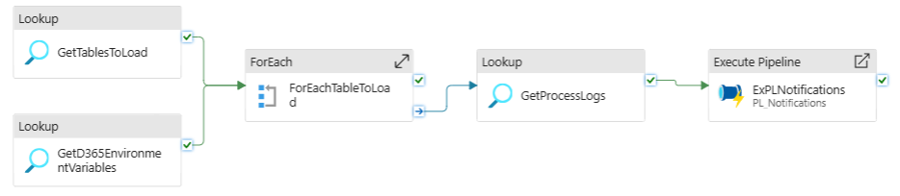
Figure 10 PL_D365_STAGE
PL_STAGE_D365 – Extracts tables from D365 source into Synapse dedicated pool staging layer with logging, error handling, and notifications.

Configurations
Type | Name | Purpose
Parameter | SourceSystem | Identifies the source system (default: Ice).
Parameter | ProcessID | Tracks process execution identifier (default: 11).
Parameter | FlowType | Type of flow being executed, e.g., Extract.

Activities
Activity Type | Activity Name | Purpose | Database Object  Used
Lookup | GetTablesToLoad | Fetches list of tables to load for given SourceSystem, FlowType, ProcessID. | [ELT].[GetTablesToLoad]
Lookup | GetD365EnvironmentVariables | Retrieves environment-specific variables for D365 integration. | [config].[GetD365EnvironmentVariables]
ForEach | ForEachTableToLoad | Iterates through each table to load (in parallel batches of 5). | Based on GetTablesToLoad output
Copy | CopySourceToSink | Copies data from D365 source into Synapse staging tables. Handles truncate for full load. | Dataset: DS_SYN_LINK_D365_QUERY, DS_SYN_DEDICATED_POOL_TBL
Lookup | UpdateProcessLogsOnFailure | Logs failure details if copy activity fails. | [ELT].[UpdateProcessLog]
Lookup | UpdateProcessLogsOnSuccess | Logs success details (row counts, inserts, errors) after copy completes. | [ELT].[UpdateProcessLog]
Lookup | GetProcessLogs | Retrieves error counts and duration for pipeline execution. | [ELT].[GetProcessLogErrorCount]
ExecutePipeline | ExPLNotifications | Calls notification pipeline with run ID, name, duration, error count. | PL_Notifications

Flow Summary
- Initialization
  - Pipeline receives parameters (SourceSystem, ProcessID, FlowType).
  - Variables (TableLogs, TableLogString, TableLogTemplate) are initialized.
- Environment Setup
  - GetTablesToLoad → Fetch list of tables to be processed from [ELT].[GetTablesToLoad].
  - GetD365EnvironmentVariables → Retrieve environment-specific connection and configuration details.
- Table Processing Loop
  - ForEachTableToLoad iterates through each table (up to 5 in parallel).
    - CopySourceToSink → Copies data from D365 (source query) into Synapse staging table.
      - Performs truncate if full load (non-incremental).
      - Stages data in ADLS for intermediate transfer.
    - UpdateProcessLogsOnSuccess → On success, logs row counts, inserts, and run details in [ELT].[UpdateProcessLog].
    - UpdateProcessLogsOnFailure → On failure, logs error message, error counts, and execution details in [ELT].[UpdateProcessLog].
- Pipeline Logging
  - GetProcessLogs → Summarizes error count and total run duration from [ELT].[GetProcessLogErrorCount].
- Notifications
  - ExPLNotifications → Invokes PL_Notifications pipeline to send a final execution summary (RunId, PipelineName, Duration, ErrorCount).
- Completion
  - Pipeline ends after notifications.
  - All logs are stored in Synapse control tables and staging data is left in ADLS with date-based folder structure.

Notes
- Parallelism: ForEach supports up to 5 tables concurrently.
- Staging: Data is temporarily staged in ADLS (LS_SYN_ADLS) under a date-based folder path.
- Error handling: Failures update logs with error messages and file paths.
- Notifications: Final step triggers notification pipeline with summary stats.

Loading tables from ICE & Workbench Audit

Pipeline Name: PL_AUDIT_ENHANCED
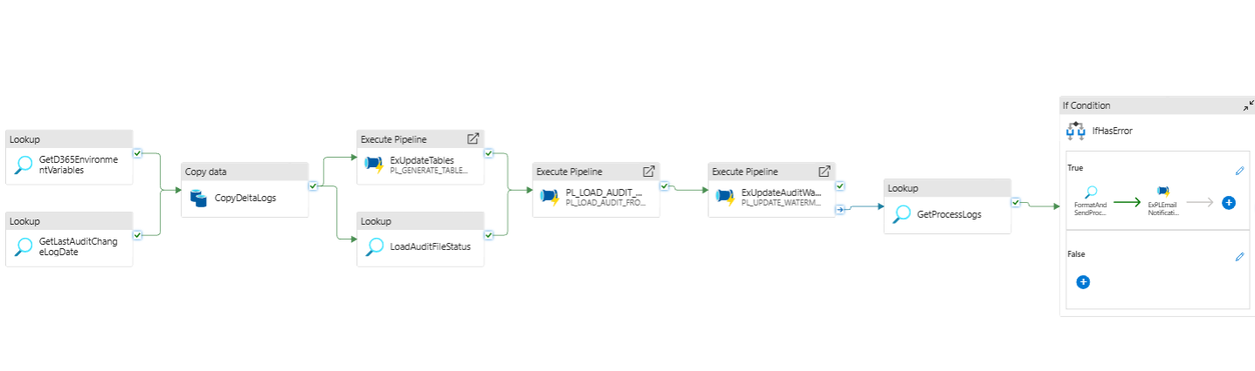
Figure 11 PL_AUDIT_ENHANCED

Folder: D365/Audit

Purpose
Ingest and process Delta Lake _delta_log files for a source system, load parsed audit change-log records into the Synapse dedicated pool table ELT.AuditChangeLogData, update related audit/watermark controls, and (if errors are detected) format and send a process summary email notification.

Pipeline Configuration
Type | Name | Purpose
string | SourceSystem | Identifies the upstream system (e.g., D365) and is used for stored procedure parameters, table filtering, and email summary. Default: ice. [PL_AUDIT_ENHANCED | Txt]
string | FilePath | ADLS folder path prefix for audit data; used to locate the Delta Lake _delta_log/ JSON files (e.g., deltalake/audit_partitioned/).
string | ADFProcessID | Internal process identifier used in process logging and email summaries. Default: 201.
string | EmailProfile | Email configuration/profile used by the notification sub-pipeline. Default: D365DataLayerProfile.

Activities
Activity Type | Activity Name | Purpose | Database Object Used
Lookup | GetD365EnvironmentVariables | Fetch environment values (e.g., DatabaseName, SynapseWorkspace) for the current SourceSystem. First row is used to derive the ADLS container and audit DB name. | Stored proc: config.GetD365EnvironmentVariables (dataset: DS_SYN_DEDICATED_POOL_PROC)
Lookup | GetLastAuditChangeLogDate | Retrieve the last processed audit change log datetime for the SourceSystem to bound incremental reads from _delta_log. | Stored proc: ELT.GetLastAuditChangeLogDate (dataset: DS_SYN_DEDICATED_POOL_PROC)
Copy | CopyDeltaLogs | Read JSON entries from ADLS _delta_log/ (filtered by datetime from the previous lookup to NZ Standard Time), add columns (LogFileName, SourceSystem), map Delta commit fields to tabular columns, and load into ELT.AuditChangeLogData. Pre-copy deletes existing rows for the SourceSystem. | Source: ADLS JSON via DS_AUDIT_DELTALOG_JSON; Sink: Synapse table via DS_SYN_DEDICATED_POOL_TBL targeting ELT.AuditChangeLogData. Pre-copy script: DELETE FROM ELT.AuditChangeLogData WHERE SourceSystem = '<SourceSystem>';
Lookup | LoadAuditFileStatus | Evaluate imported audit file statuses and produce a list of files to load via downstream pipeline; logs with PipelineRunID. | Stored proc: ELT.LoadAuditFileStatus (dataset: DS_SYN_DEDICATED_POOL_PROC)
ExecutePipeline | ExUpdateTables | Generate/refresh table load control for Audit catalog, using environment variables and process ID; runs PL_GENERATE_TABLES_LOAD_CONTROL_AUDIT. | Child pipeline: PL_GENERATE_TABLES_LOAD_CONTROL_AUDIT (parameters: TableCatalog, DropAndRecreate, ADFProcessID, AuditDBName)
ExecutePipeline | PL_LOAD_AUDIT_FROM_ADLS | Orchestrate audit file ingestion from ADLS for the provided file list and container; passes parent run ID for lineage. Depends on LoadAuditFileStatus and ExUpdateTables. | Child pipeline: PL_LOAD_AUDIT_FROM_ADLS (parameters: SourceSystem, FilePathPrefix, FileList, Container, ParentPipelineRunID)
ExecutePipeline | ExUpdateAuditWaterMarkValue | Update the watermark value for the audit processing using PL_UPDATE_WATERMARKVALUE. Runs after ADLS load completes. | Child pipeline: PL_UPDATE_WATERMARKVALUE (parameters: ADFProcessID, SourceSystem)
Lookup | GetProcessLogs | Retrieve error counts for the current pipeline run ID to drive conditional notification. | Stored proc: [ELT].[GetProcessLogErrorCount] (dataset: DS_SYN_DEDICATED_POOL_PROC)
Lookup | FormatAndSendProcessSummary | Generate HTML summary, subject, and body for email notifications using process metadata. Produces HtmlSummary, HTMLSummary, and EmailSubject. | Stored proc: ELT.FormatAndSendProcessSummary (dataset: DS_SYN_DEDICATED_POOL_PROC)
IfCondition | IfHasError | Check ErrorRowCount > 0; if true, trigger email notification. | Expression: @greater(activity('GetProcessLogs').output.firstRow.ErrorRowCount, 0)
ExecutePipeline (in IfTrue) | ExPLEmailNotification | Send process summary email using the generated HTML and subject; uses the configured EmailProfile. Waits on completion. | Child pipeline: PL_EMAIL_NOTIFICATION (parameters: HttpRequestBody, EmailProfile, Body, Subject)

Flow Summary
- Environment bootstrap: Read Synapse/Database context via GetD365EnvironmentVariables and the last processed change-log datetime via GetLastAuditChangeLogDate.
- Delta _delta_log ingestion: CopyDeltaLogs reads JSON logs from ADLS using wildcard path FilePath + '_delta_log/', constrained between the last log datetime and current time converted to New Zealand Standard Time; maps commit fields (e.g., commitInfo.timestamp, add.path, add.partitionValues.PartitionId) into ELT.AuditChangeLogData. Pre-copy, deletes existing rows for the SourceSystem.
- Status & control: LoadAuditFileStatus produces the list of files to load; ExUpdateTables refreshes audit load control metadata for the catalog <SourceSystem>Audit.
- ADLS file load orchestration: PL_LOAD_AUDIT_FROM_ADLS ingests the file list into target structures with lineage (ParentPipelineRunID).
- Watermark update: ExUpdateAuditWaterMarkValue runs to persist the latest processed state.
- Monitoring & notification: GetProcessLogs checks errors; IfHasError conditionally triggers ExPLEmailNotification after FormatAndSendProcessSummary prepares the email content.

Key Notes & Call-outs
- Time zone handling: The end filter for _delta_log reads uses @convertTimeZone(utcNow(), 'UTC', 'New Zealand Standard Time'), ensuring alignment with local operational windows. Consider daylight-saving impacts if moving to NZDT.
- First-row lookups: Environment variables are drawn from the first row of the initial lookup; ensure the proc always returns a single, authoritative configuration row.
- Pre-copy delete: CopyDeltaLogs executes a DELETE against ELT.AuditChangeLogData for the SourceSystem before insert. Validate that this aligns with idempotency and retention requirements, as it will replace all prior rows for that source.
- Partition awareness: Mappings include add.partitionValues.PartitionId; confirm downstream tables/indexes leverage this for efficient querying.
- Error-driven email: Email is sent only when ErrorRowCount > 0. If you want success summaries, add an IfFalse branch to trigger a success notification.
- Dependencies: Key orchestration gates:
  - CopyDeltaLogs waits on both environment and last-date lookups.
  - PL_LOAD_AUDIT_FROM_ADLS waits on file status and table control update.
  - Email notification depends on formatted summary output.
- Datasets in use:
  - DS_SYN_DEDICATED_POOL_PROC for stored procedures.
  - DS_AUDIT_DELTALOG_JSON for ADLS JSON source.
  - DS_SYN_DEDICATED_POOL_TBL for table sink (schema: ELT, table: AuditChangeLogData).

Pipeline Name: PL_MAIN_STAGE_TRANSFORM_D365_AUDIT_NEW
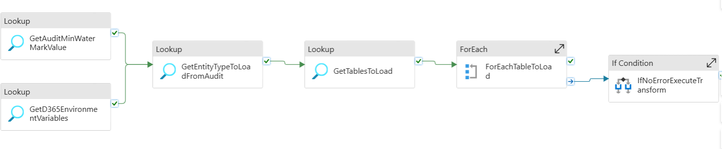
Figure 12 PL_MAIN_STAGE_TRANSFORM_D365_AUDIT_NEW

Purpose
The pipeline orchestrates the staging and transformation of Dynamics 365 (D365) source data into Synapse Dedicated SQL Pool. It loads table-level data from D365 using metadata-driven logic, performs transformations, and maintains detailed process logs for auditing and notification.

Configurations
Type | Name | Purpose
Parameter | SourceSystem | Identifies the source system (default: Ice).
Parameter | ProcessID | Unique process identifier for orchestration and logging (default: 11).
Parameter | FlowType | Determines load type (default: Extract).

Activities
Activity Type | Activity Name | Purpose | Database Object Used
Lookup | GetTablesToLoad | Fetches list of tables to be processed based on parameters. | [ELT].[GetTablesToLoad]
Lookup | GetD365EnvironmentVariables | Retrieves D365 environment configuration (DB name, workspace, etc.). | [config].[GetD365EnvironmentVariables]
ForEach | ForEachTableToLoad | Iterates through tables retrieved and executes copy & log activities. | N/A
Copy | CopySourceToSink | Copies data from D365 (source query) to Synapse target table. | Dynamic: DS_SYN_LINK_D365_QUERY → DS_SYN_DEDICATED_POOL_TBL
Lookup | UpdateProcessLogsOnFailure | Updates process log when copy activity fails, capturing error message. | [ELT].[UpdateProcessLog]
Lookup | UpdateProcessLogsOnSuccess | Updates process log when copy activity succeeds, capturing row counts. | [ELT].[UpdateProcessLog]
Lookup | GetProcessLogs | Aggregates pipeline-level log results including error counts. | [ELT].[GetProcessLogErrorCount]
ExecutePipeline | ExPLNotifications | Triggers notification pipeline with execution details. | PL_Notifications

Flow Summary
- Initialization – Pipeline parameters and environment variables are loaded.
- Metadata Driven Table Selection – Tables to be processed are fetched dynamically from [ELT].[GetTablesToLoad].
  - CopySourceToSink → Copies data from D365 (source query) into Synapse staging table.
    - Performs truncate if full load (non-incremental).
    - Stages data in ADLS for intermediate transfer.
  - UpdateProcessLogsOnSuccess → On success, logs row counts, inserts, and run details in [ELT].[UpdateProcessLog].
  - UpdateProcessLogsOnFailure → On failure, logs error message, error counts, and execution details in [ELT].[UpdateProcessLog].
- Process Logging – A summary of all execution results is retrieved via [ELT].[GetProcessLogErrorCount].
- Notifications – Final execution metrics (duration, error count, run ID) are passed to PL_Notifications for alerting.

Key Notes
- Metadata-driven: Tables and queries are dynamically determined.
- Parallel execution: Up to 5 tables load simultaneously, improving performance.
- Full logging framework: Success and failure logs are both captured centrally.
- Notifications: Final status and metrics are shared externally for monitoring.

Development Standards

Coding Standards
Common sense development standards apply. The code needs to be tidy and readable, but the formatting of code is not mandated by this design document.
The key naming standards are:
- PascalCase notation for naming if the resource supports it, otherwise lowercase
- Retain source system table names for the ODS
- Pluralise object names that contain collections, e.g. DimCustomers
- Singularise key names for objects referencing collections, e.g. DimCustomerKey
- Singularise object names where a single entity is expected
- Suffix the environment name in objects, including production, where required (DEV, SIT, UAT, PRD)
- Standardise the object names where they are contained in an environment specific object, such as pipelines within an environment specific Data Factory
- Do not use spaces in object naming
- Do not use reserved keywords (See reference list)
- Do not prefix object names where such as sp_ for stored procedures
- Prefix object names where conflicts or ambiguity is possible such as FK_ for foreign keys

General standards are:
- Normalise to third normal form where there are no performance compromises
- Preference for varchar columns where appropriate
- Use nvarchar only where multi-byte data is possible
- All constraints must be named, including default constraints
- All Solutions and Projects must have a per environment configuration created named Development, UAT and Production
- When creating or editing a database project ensure it has appropriate publish profiles for each environment for each database

All code must go through peer review. Peer reviews are scheduled and managed by the Technical Lead.

Development Toolset
Use a version of SQL Server Data Tools (Visual Studio Code, Azure Data Studio)

Devops & CICD

Source Code Control
Source Code control is provided through the Azure Devops. Visual Studio with integration is the default client and where possible the necessary Azure templates will be added to the repository.
Item | Value
Location | Summary - Overview
Repository Type | Git
Client | Visual Studio, Azure Data Studio where possible

Repositories
Repo Name | Purpose
Synapse_Pipeline_Repo | Stores Synapse related artifacts including pipelines, linked services, triggers, etc.
Synapse_SQL_REPO | Stores SQL objects such as tables, stored procedure and functions.

Pipelines
Repo Name | Purpose
Synapse_Deploy_to_<Environment>  Where Environment is Prod or Test | Deploys artifacts to Synapse workspace
Synapse_SQL_REPO | Deploys SQL objects to Synapse dedicated SQL pool

Service Connections
Connection Name | Environment & Purpose
dl-DeploymentSpn-test | Test environment –  Service connection for deploying Synapse workspace and objects to Synapse dedicated sql pool. This service connection has access to deploy to synapse workspace and dedicated sql pool
dl-DeploymentSpn-prod | Production environment  Service connection for deploying Synapse workspace and objects to Synapse dedicated sql pool. This service connection has access to deploy to synapse workspace and dedicated sql pool

Environments
An environment represents a logical target where your pipeline deploys software. Common environment names include Dev, Test, QA, Staging, and Production
https://learn.microsoft.com/en-us/azure/devops/pipelines/process/environments?view=azure-devops#create-an-environment
Name | Purpose
Synapse_prod | Prod environment for Synapse workspace
Synapse_test | Test environment for Synapse workspace
Synapsesql_prod | Prod environment for Synapse dedicated sql pool
Synapsesql_test | Test environment for Synapse dedicated sql pool

Branching Strategy
A branching strategy known as Feature + Release Isolation will be used. This provides the most simplified mechanism for a three-tier environment of Development, UAT (Release) and Production (Main) where multiple work streams can be active in parallel. It has a low merge debt if feature development is a short process and a simplified UAT release cycle and makes it easier for multiple developers to contribute to multiple features.
This is described in more detail here. The Git Flow and BitBucket equivalent is documented here.
Feature isolation ensures there is always a consistent source of truth for the code base that reflects the active development state (Development) and there is no risk of feature development polluting the code base of production and hampering other development efforts (isolated features). This reduces risk as well and allows for a feature to be descoped with no impact to the code base.

Figure 13 Feature isolation
Release isolation ensures releases to UAT and Production are controlled through a separate branch and back merged to both Development and Production (Master) when completed in UAT.

Figure 143 - Release Isolation

Main Branch
The main branch represents the current production environment. This is used as a baseline for production releases.

Development Branch
The development branch represents the current, development branch of source code with a collection of features that are available for release. This is used as the starting point for any releases to a higher environment.

Feature branch
A feature branch holds the code for an isolated feature usually until developer testing of that feature is completed. It is back merged to development when completed and ready for release to a higher environment.
It is possible to have multiple features in parallel development at one time with the code for each one isolated in their own feature branches.
The feature branch is created from the Development branch and at the start is identical to the Development branch.
Development occurs within the feature branch.
Forward integration from the Development branch is done periodically to capture any Development branch changes from hotfixes or other features completing as part of feature development.
Once the Feature is done and ready for UAT the Feature branch is integrated to the Development branch.
A new Release branch is created from the Development branch for UAT.
If accepted in UAT the Release is integrated back to the Development branch and Master (Production) branch.
If rejected in UAT the Release is dropped and rolled back through a new feature.

Release branch
A release branch is created from the Development branch to represent the UAT environment. This allows for isolated hotfixes during the UAT period to the current state of the development release.

Deployments – How to guide

Deployment in Synapse
Deployment of Synapse artifacts (pipelines, datasets, linked services) follows a controlled workflow to ensure changes are correctly promoted from development to production environments with minimal disruption.

Deployment Steps
- Branching and Development
  - Create a feature/fix branch from the main branch.
  - Implement the required fix or enhancement in the development environment.
  - Test changes locally in Dev workspace.
- Collaboration and Publishing
  - Merge the feature branch back into the main branch after code review.
  - Publish the workspace from the Dev environment.
  - This action updates the workspace_publish branch with all published artifacts.
- Deployment to Target Environment
  - Trigger the deployment pipeline: Synapse_Deploy_to_<Environment>
  - The deployment pipeline uses the workspace_publish branch as the source.
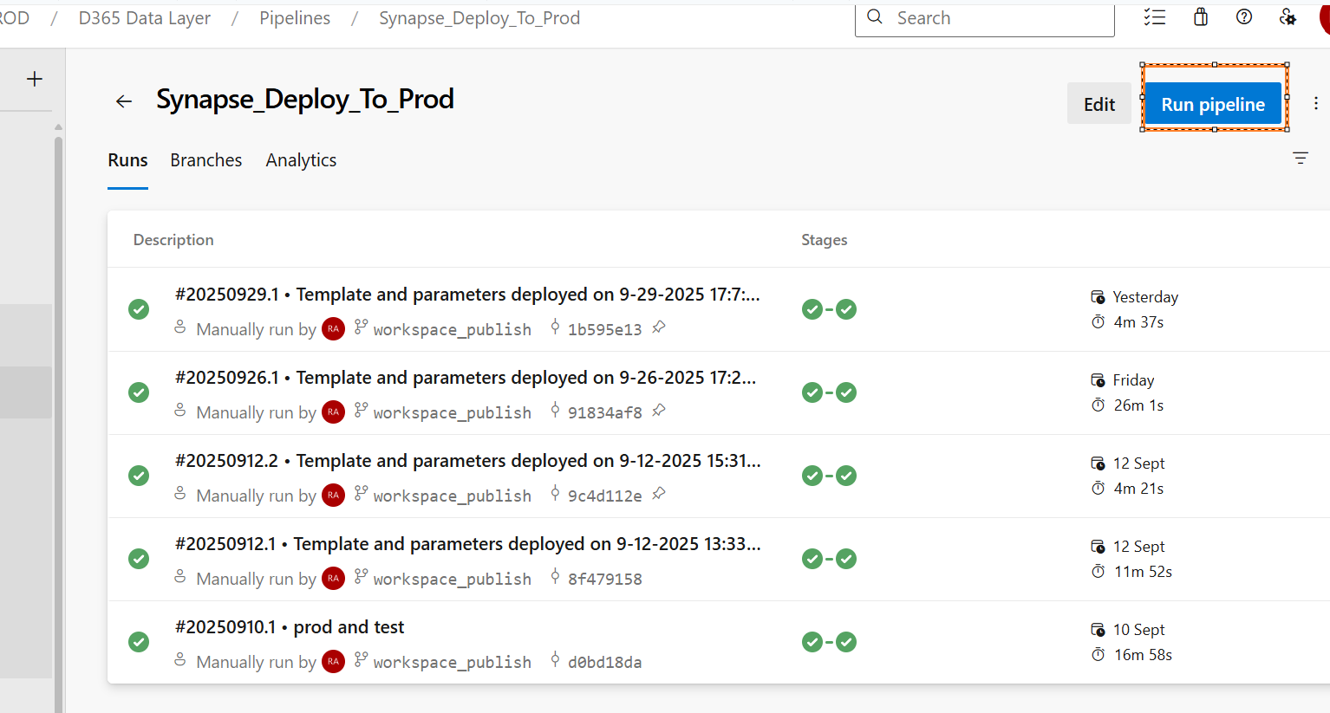
Figure 15 Synapse Pipelines
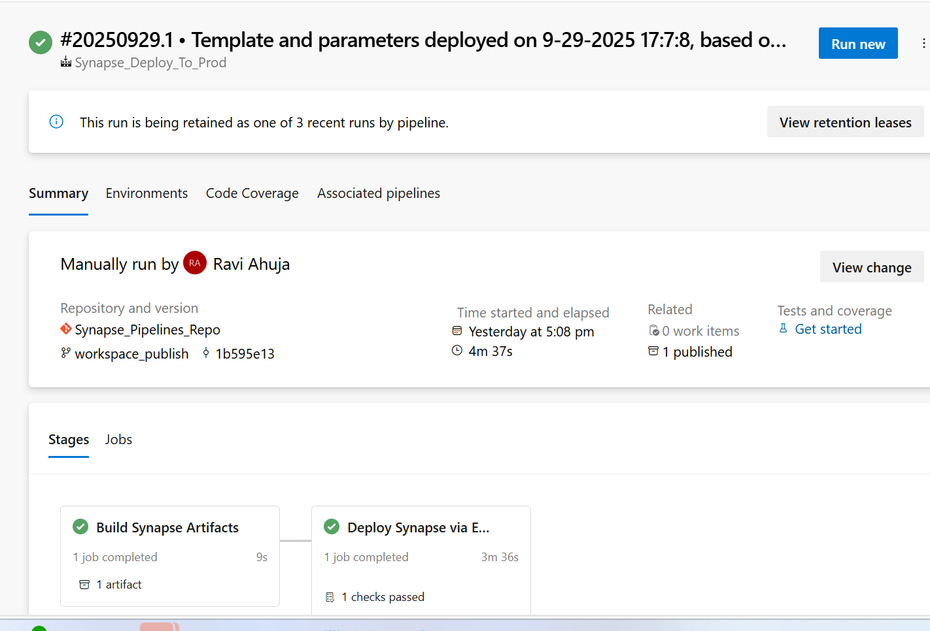
Figure 16 Synapse Approval and deployment steps
- Review and Approval
  - Review the changes applied in the target environment.
  - Verify that all artifacts, parameters, and triggers are correctly updated.
  - Approve the deployment once confirmed.

- Deployment Workflow
During deployment, the pipeline performs the following automated steps:
Step | Description
Stop Triggers | Temporarily disables any active triggers to avoid executing pipelines during deployment.
Deploy Artifacts | Deploys all updated Synapse artifacts (pipelines, datasets, linked services) from the workspace_publish branch to the target environment.
Start Triggers | Re-enables the triggers once the deployment is successfully completed.

- Override Parameters
- The deployment process allows overriding certain parameters defined in the Synapse workspace.
- These override values can be provided in the YAML configuration file used by the deployment pipeline.
- Examples of override parameters:
  - Environment name (Dev/Test/Prod)
  - Specific dataset or pipeline version
  - Trigger states
- 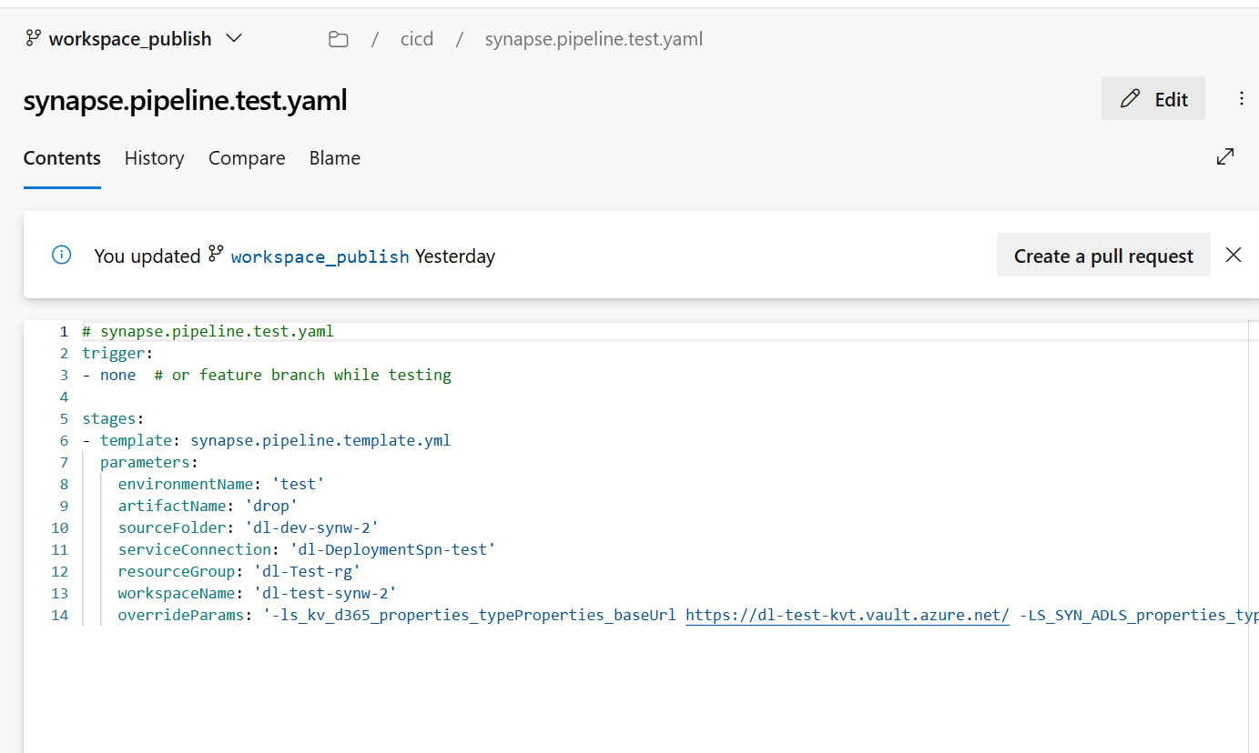
Figure 17 Synapse Pipeline YAML

- Best Practices
- Always validate your changes in the Dev environment before merging to main.
- Document any parameter overrides in the YAML file for reproducibility.
- Confirm that all triggers are restored to their correct state post-deployment.

Deployment in Synapse Dedicated SQL Pool

Overview
Deployment of SQL artifacts (tables, views, stored procedures, post-deployment scripts) in a Synapse Dedicated SQL Pool follows a controlled process to ensure consistency, maintain history, and safely promote changes from development to production.

Deployment Steps
- Preparation
  - Take the latest changes from the main branch.
  - Sanity check (temporary): Compare the schema between production and main branch using Azure Data Studio → Schema Compare to ensure they match.
  - Take the latest changes into your feature branch.
  - Apply any changes from production to the feature branch to sync with current prod state.
- Development
  - Apply your fixes or enhancements in the feature branch.
  - Post-testing, merge changes into the main branch.
- Post-Deployment Script Management
  - Any post-deployment SQL scripts must be added to the Scripts folder.
  - Update the .sqlproj file to exclude these scripts from normal build.
Example in the .sqlproj file:
  - <ItemGroup>
  - <None Include="Scripts\ELT.NotificationConfig.Table.sql">
  - <ExcludeFromBuild>true</ExcludeFromBuild>
  - </None>
  - </ItemGroup>
  - Always backup metadata tables before making changes, and maintain a history table for auditing.
  - Call your post-deployment scripts in Script.PostDeploymentMDP.sql using the :r syntax:
E.g. : :r .\ELT.NotificationConfig.Table.sql
- Code Review and Merge
  - Merge your changes to the main branch after completing testing.
  - Perform a code review to ensure correctness and compliance with standards.
- Deployment Pipeline
  - Run the deployment pipeline for the SQL pool.
  - This pipeline will:
    - Build the artifact.
    - Generate a compare script showing differences between the source and target environment.
  - Review the compare script carefully and approve the deployment.
- Post-Deployment Verification
  - Validate that all scripts executed successfully.
  - Confirm that tables, views, and procedures are deployed correctly.
  - Check triggers, metadata tables, and post-deployment changes for correctness.

Best Practices
- Always backup metadata tables before making changes.
- Maintain history tables for audit purposes.
- Use post-deployment scripts for changes that require controlled execution order.
- Ensure schema comparison is performed if unsure about environment drift.
- Document parameter overrides or special deployment instructions.

Process to access D365 data layer by new team

Overview
The D365 Data Layer contains raw data persisted from Dataverse Synapse Link tables into the SQL Dedicated Pool. This data is read-only and intended for teams that need to consume it for analytics or downstream processing.

Access Principles
- Read-only access to raw schema.
- Direct access for reporting tools (e.g., Power BI) is not permitted.
- Consumers must extract and persist data into their own platform before using it for reporting or analytics.

Access Methods
- Azure Managed Identity:
  - Teams accessing via Azure Data Factory (ADF) or Synapse pipelines or Azure services can use a managed identity or a service principal.
  - Grant read access to the required schema in the dedicated pool.

Named SQL Authentication Users:
  - Allowed only through WNZL network.
  - Typically used for service accounts or legacy integration scenarios.

Connectivity Requirements
- Managed Private Endpoint:
  - Required from the source environment (team’s ADF/Synapse) to the target (D365 Data Layer Synapse workspace).
  - Ensures secure, private connectivity.
- Approval Process:
  - Submit a Change Request to the Engineering team for endpoint creation and inbound request approval.
  - No direct public access is allowed.

Restrictions
- No direct Power BI access:
  - Teams must stage data in their own environment before reporting.
- Raw format:
  - Data is not modeled for reporting; consumers must apply transformations.

Performance & Resource Management
- Max Concurrent Queries: 4 queries at DW100c service level.
- Query Queuing:
  - When concurrency exceeds 4, queries are queued internally.
- Resource Classes:
  - Parallelism depends on resource class assigned to the query.
  - Heavy queries may block others; plan workloads accordingly.

Onboarding Steps

Request Access:
  - Submit an onboarding request specifying:
    - Purpose of access.
    - Required schemas/tables.
    - Access method (Managed Identity or SQL Auth).

Network Setup:
  - Engineering team creates Managed Private Endpoint.
  - Validate connectivity from source to target.

Grant Permissions:
  - Assign read-only role to managed identity or named user.

Test Connectivity:
  - Validate ADF/Synapse linked service using managed identity.

Data Handling:
  - Extract raw data and persist in your own platform.
  - Apply transformations for reporting.

Compliance Check:
  - Ensure usage aligns with data governance and security policies.

Key Notes
- Cost Awareness:
  - Avoid heavy queries during peak hours.
  - Consider partition pruning and incremental loads.
- Monitoring:
  - Track query performance and concurrency.
- Change Management:
  - Any schema changes or new endpoint requests require a formal change request.

Weekly Data Reconciliation Pipeline Documentation

Overview
We have implemented a weekly data reconciliation pipeline to ensure data consistency between source systems and target tables. This process helps identify discrepancies and maintain data integrity across environments.

Schedule
- Workbench Pipeline: Runs every Sunday at 10:00 AM.
- Ice Pipeline: Runs every Sunday at 10:30 AM.

Process Flow
- Watermark-Based Query Execution
  - The pipeline retrieves the watermark value from the MainControl table.
  - It uses this watermark to query both source and target systems for the relevant data range.
- Record Count Comparison
  - The pipeline calculates the record counts for source and target tables.
  - These counts are logged into the Reconciliation Log Table for auditing and reporting.
- Discrepancy Handling
  - If discrepancies are detected (e.g., counts do not match):
    - The affected table can be truncated and reloaded.
    - This step is essential when:
      - Data goes out of sync.
      - A re-sync occurs in Dataverse.

Logging
- All count checks are stored in the Reconciliation Log Table.
- This table serves as the single source of truth for monitoring data consistency.

Power BI Reporting
- a Power BI report leveraging the Reconciliation Log Table.
- The report provides:
  - Count Check Visualization (Source vs Target).
  - Ability to identify anomalies quickly.
  - Drill-down capability for detailed analysis.
- D365 Logging & Monitoring - Power BI

Database objects
Object Type | Object Name | Purpose
Table | ELT.ReconcilationLogs | Run-time reconciliation log store. Captures PipelineID, RunDate (via ELT.ufn_ConvertUTCtoNZT(GETDATE())), ELTControlID, WaterMarkValue, and the latest TotalSourceRecords / TotalTargetRecords. Used for reporting/auditing and for later replays.
View | ELT.vw_ReconcilationCountQueries | Generates query templates to count rows on source/target. Source query is wrapped as a subquery; Target remains “as-is.” Chooses COUNT(DISTINCT ID) only when the target has a ModifiedOn column, otherwise COUNT(1). Adds WHERE SinkModifiedOn <= '{WaterMarkValue}' when IncrementalLoad = 1. Emits flags HasModifiedOn and IsIncrementalLoad, plus optional MIN/MAX(SinkModifiedOn) when incremental.
View | ELT.vw_CountChecks | Reporting view that joins ELT.ReconcilationLogs with control metadata (via ELT.vw_ControlInfo) and the query templates from ELT.vw_ReconcilationCountQueries. Substitutes {WaterMarkValue} in the templates with the log’s watermark for reproducible counts. Shows TotalSourceRecords, TotalTargetRecords, RecordDiff, RunDate, and resolved SourceCountQuery/TargetCountQuery.
Stored Procedure | ELT.UpdateReconcilationLog | Updates the data in Reconcilationlogs table with source and target counts along with SinkModified (min and max) dates for source and target
Stored Procedure | ELT.GetReconcilationCountQueries | Returns ready-to-execute Source/Target count SQL strings by reading ELT.vw_ReconcilationCountQueries and replacing the {WaterMarkValue} placeholder with the ISO-8601 WaterMarkValue from control metadata. Also returns ELTControlID, SourceSystem, HasModifiedOn, and IsIncrementalLoad. Used by ADF to run counts.

Notes & Usage
- Placeholders: ELT.vw_ReconcilationCountQueries emits {WaterMarkValue} inside its WHERE clauses; ELT.GetReconcilationCountQueries replaces this with a formatted datetime2(7) literal (YYYY-MM-DD HH:MM:SS.fffffff).
- Counting rule: COUNT(DISTINCT ID) is used only if the target table contains a ModifiedOn column and IncrementalLoad = 1; otherwise COUNT(1). The SinkModifiedOn predicate is applied when incremental.
- Source wrapping: The source base SQL (from control metadata) is wrapped as a subquery when building the count string, ensuring any existing filters/joins are preserved before aggregation.
- Logs vs Control: vw_CountChecks substitutes {WaterMarkValue} using the log’s watermark (for historical reporting); the stored procedure substitutes using control metadata (for current operational runs).

Benefits
- Automated weekly checks reduce manual effort.
- Early detection of data mismatches prevents downstream issues.
- Provides transparency and auditability through centralized logging and reporting.

Key Considerations for Dedicated SQL Pool Deployment
This section highlights critical practices and considerations when deploying ELT and Config-related objects in Synapse Dedicated SQL Pool. Following these ensures consistency, compliance, and minimal disruption during deployment.

Objects in Source Control
- Only ELT and Config-related objects are maintained in source control for the dedicated SQL pool.
- This includes pipelines, tables, views, stored procedures, and metadata/configuration scripts relevant to ELT processes.

Handling Schema Drift
When schema changes are detected (e.g., adding or updating columns), follow these steps:
Step A: Column Comparison
- Compare the columns between the source definition and the current database.
- Check if PII/PCI mapping is defined for new columns.
  - If a mapping exists and is not present in the database:
    - Add it via a post-deployment script.
Example: Scripts\ICE_PII_PCI_Mapping.sql
    - Include this script in Script.PostDeploymentMDP.sql to ensure execution during deployment.
Step B: Existing Objects
- Check the table volume before making changes.
  - Truncate the table if required to avoid conflicts during schema updates.
- Update the watermark value in the MainControl table:
  - Either set to 1900-01-01 or the start of a financial year.
Example: 2023-09-30
Step C: New Objects
- Verify entries for the new table in MainControl and ControlFlow tables.
- Note down the ADFProcessID associated with the new object.
- Trigger management:
  - If the ADFProcessID already has a trigger defined, no action is needed.
  - If it’s a new ADFProcessID, create a trigger and schedule it according to the required frequency in the Synapse workspace.
  - Do the required deployments for trigger to the synapse workspace

Step D: Post-Deployment Actions
- Run the deployment pipeline and verify that all changes are applied correctly.
- After deployment, execute the PL_Main_Bootstrap pipeline:
  - Ensure the parameter DropAndRecreateTable = false to avoid accidental truncation of production tables.
- Confirm that triggers, metadata, and ETL processes are functioning as expected.

Best Practices
- Always review PII/PCI mappings before adding new columns.
- Maintain backups and history tables for all metadata changes.
- Validate watermark values for incremental loads to avoid duplicate or missing data.
- Document new ADFProcessIDs and triggers to ensure proper scheduling.

Required Access
Role | Purpose
Purpose
ZS_Proxy_Public_Cloud_Console_Access | Cloud console access
WNZLTest-Access-AzureSubscriptions-EIS-D365DataLayer-Contributor | Access to SQL Endpoints of D365. Mainly the dedicated sql pool and workspaces
WNZL-Access-Azure-pbi-D365 Data Layer-Member  WNZL-Access-Azure-pbi-D365 Data Layer-Contributor  WNZL-Access-Azure-pbi-D365 Data Layer-Viewer  WNZL-Access-Azure-pbi-D365 Data Layer-App | Other AD Groups for Power BI Workspace.  Access as per the name
WNZL-Access-Azure-pbi-D365 Data Layer-Admin | Power BI Workspace for D365 Data Layer
WNZL-Access-Azure-EIS-D365DataLayer-Contributor | Prod Access to D365 resources
WNZL-Access-Azure-ADO-D365DL-Data-Engineers | Access to Azure Devops for data engineers
Restricted-UAC-Azure-EIS-Prod | Required to access resources behind private endpoints via client tools such as SSMS, Power BI Desktop
Restricted-UAC-Azure-EIS | Required to access resources behind private endpoints via client tools such as SSMS, Power BI Desktop
CorpTestNZ-Access-AzureSubscriptions-ICE-Contributor | ICE Contributor access
CorpNZ-Access-O365-Azure-DevOps | O365 access to Azure Devops
Corpnz-access-D365-WNZLOps | Members of this group will have access to the Power Platform Environment "WNZL Operations" - this Environment has a Dataverse database instance.
Corpnz-access-D365-PRODUCTION | Members of this group will have access to Dynamics 365 Production
Power BI Report for Logging & Monitoring | ETL Logs - D365 Logging & Monitoring - Power BI

Appendix – Glossary
Term | Meaning
BI | Business Intelligence  BI is a business function/process for analyzing data and presenting actionable information to help corporate executives, business managers and other end users make more informed business decisions. BI encompasses a wide variety of tools, applications and methodologies that enable organizations to collect data from internal systems and external sources, prepare it for analysis, develop and run queries against the data, and create reports, dashboards and data visualizations to make the analytical results available to corporate decision makers as well as operational workers.
DW | Data Warehouse  A large store of data accumulated from a wide range of sources within a company and used to guide management decisions. It contains low-level or atomic (indivisible) data (such as transactions and prices) with tracking of history changes. This is the place where most of the data used in current operation is housed before it's transferred to the data warehouse for longer term storage or archiving.
ELT | Extract Load Transform  ETL is short for extract, transform, load, three database functions that are combined into one tool to pull data out of one database and place it into another database.  Extract is the process of reading data from a database.  Transform is the process of converting the extracted data from its previous form into the form it needs to be in so that it can be placed into another database. Transformation occurs by using rules or lookup tables or by combining the data with other data.  Load is the process of writing the data into the target database.  ETL is used to migrate data from one database to another, to form data marts and data warehouses and to convert databases from one format or type to another.
ODS | Operational Data Store  A database designed to integrate data from multiple sources for additional operations on the data.
Data Mart | A data mart is the access layer of the data warehouse environment that is used to get data out to the users. The data mart is a subset of the data warehouse and is usually oriented to a specific business line or team.
Bus Matrix | The Bus Matrix is a data Warehouse planning tool and model created by Ralph Kimball and is part of the Data Warehouse Bus Architecture. The Matrix is the logical definition of one of the core concepts of Kimball’s approach to Dimensional Modeling – Conformed dimensions.
Fact Table | Fact tables record measurements or metrics for a specific event. Fact tables generally consist of numeric value, and foreign keys to dimensional data where descriptive information is kept. Fact tables are designed to a low level of uniform detail (referred to as "granularity" or "grain"), meaning facts can record events at a very atomic level.
Dimension Table | A dimension is a structure that categorizes facts and measures in order to enable users to answer business questions. Dimension tables usually have a relatively small number of records compared to fact tables, but each record may have a very large number of attributes to describe the fact data.
Star Schema | The star schema is the simplest style of data mart schema and is the approach most widely used to develop data warehouses and dimensional data marts. The star schema consists of one or more fact tables referencing any number of dimension tables. The star schema is an important special case of the snowflake schema and is more effective for handling simpler queries.
Master Data | Master data represents the business objects which are agreed on and shared across the enterprise. It usually covers relatively static reference data such as; customers, products, employees, materials, suppliers, and vendors.
Master Data Management (MDM) | Is the set of processes, governance, policies, standards and tools that consistently define and manage the Master Data of an organization to provide a single point of reference.
Copy Activity | An Azure Data Factory task that allows for copying data between a source and a sink. For more information see Copy Activity in Azure Data Factory.

